The Lord’s my shepherd, I’ll not want AMNS 426 Melody: Crimond C.M.
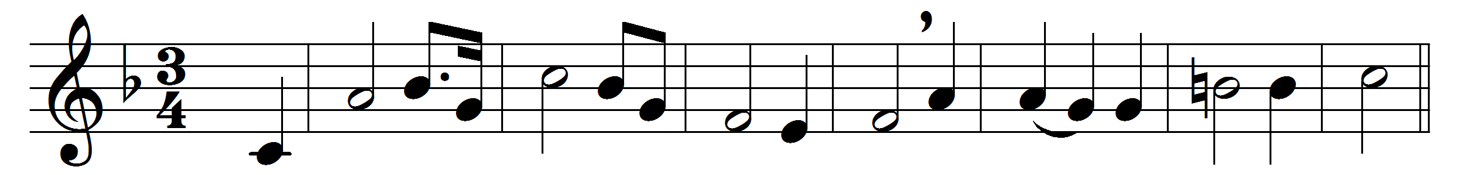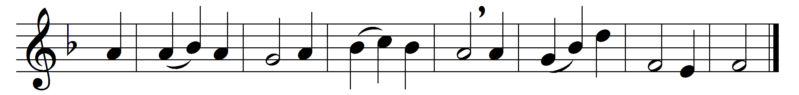

The Lord’s my Shepherd, I’ll not want;
he makes me down to lie
in pastures green; he leadeth me
the quiet waters by.
My soul he doth restore again,
and me to walk doth make
within the paths of righteousness,
e’en for his own name’s sake.
Yea, though I walk through death’s dark vale,
yet will I fear none ill;
for thou art with me, and thy rod
and staff me comfort still.
My table thou hast furnishèd
in presence of my foes;
my head thou dost with oil anoint,
and my cup overflows.
Goodness and mercy all my life
shall surely follow me;
and in God’s house for evermore
my dwelling-place shall be.

Words: Psalm 23 in Scottish Psalter, 1650
Music: Jessie Seymour Irvine (1836-1887)

