O crucified Redeemer AMNS 404 Melody: Llangloffan 7 6. 8 6. D.
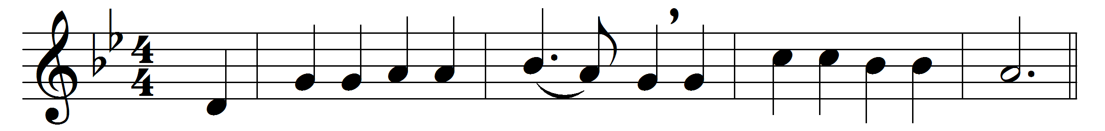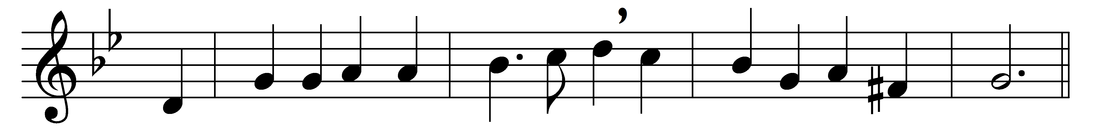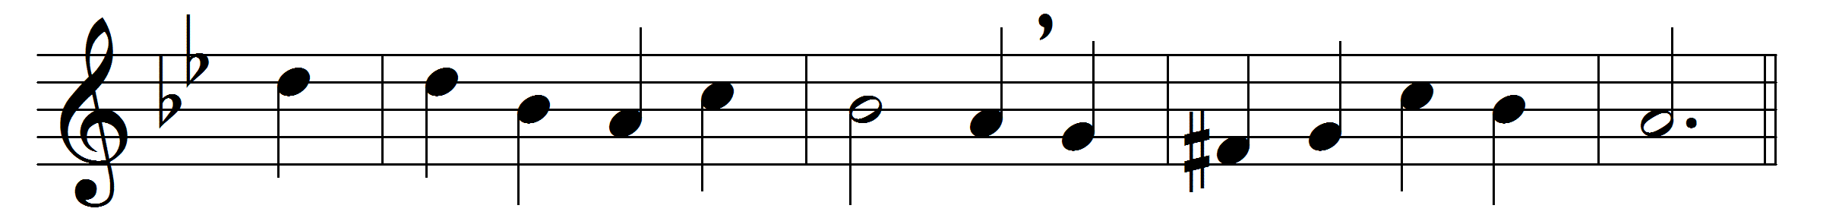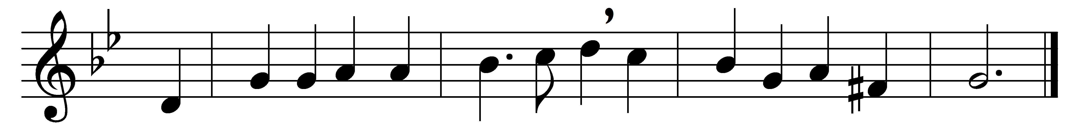

O crucified Redeemer,
whose life-blood we have spilt,
to thee we raise our guilty hands,
and humbly own our guilt.
Today we see thy Passion
spread open to our gaze;
the crowded street, the country lane,
its Calvary displays.
Wherever love is outraged,
wherever hope is killed,
where man still wrongs his brother man,
thy Passion is fulfilled.
We see thy tortured body,
we see the wounds that bleed,
where brotherhood hangs crucified,
nailed to the cross of greed.
We hear thy cry of anguish,
we see thy life outpoured,
where battlefield runs red with blood,
our brothers’ blood, O Lord.
And in that bloodless battle,
the fight for daily bread,
where might is right and self is king,
we see thy thorn-crowned head.
The groaning of creation,
wrung out by pain and care,
the anguish of a million hearts
that break in dumb despair;
O crucified Redeemer,
these are thy cries of pain;
O may they break our selfish hearts,
and love come in to reign.

Words: Timothy Rees (1874-1939)
Music: Welsh hymn melody, arranged by David Evans (1874-1948)

