Angels, from the realms of glory AMNS 39 Melody: Iris (Shepherds in the field) 8 7. 8 7. 4 7.
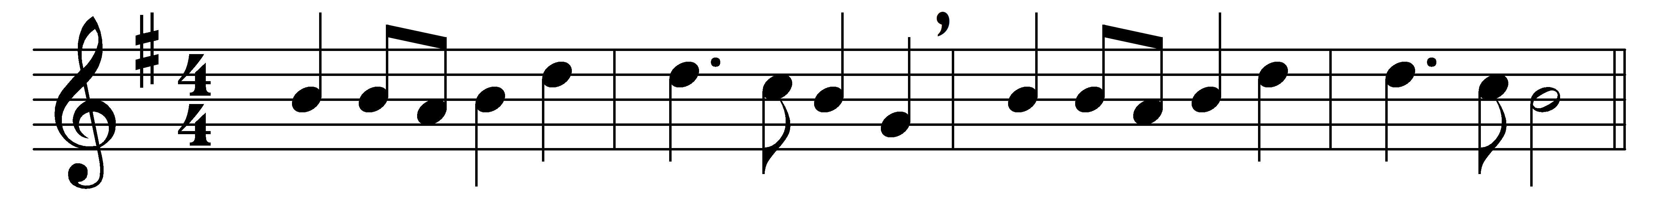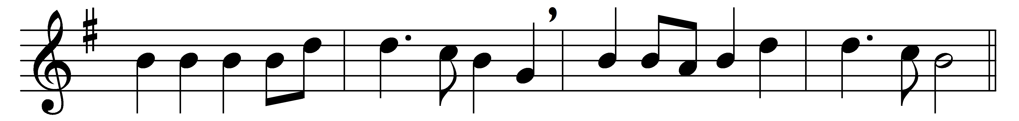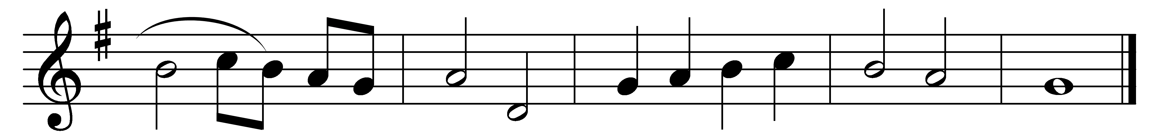

Angels, from the realms of glory,
wing your flight o’er all the earth;
ye who sang creation’s story,
now proclaim Messiah’s birth:
(Refrain:) come and worship
Christ, the new-born King:
come and worship,
worship Christ, the new-born King.

Shepherds, in the field abiding,
watching o’er your flocks by night,
God with man is now residing,
yonder shines the infant Light:
Refrain

Sages, leave your contemplations;
brighter visions beam afar:
seek the great Desire of Nations;
ye have seen his natal star:
Refrain

Saints before the altar bending,
watching long in hope and fear,
suddenly the Lord, descending,
in his temple shall appear:
Refrain

Though an infant now we view him,
he shall fill his Father’s throne,
gather all the nations to him;
every knee shall then bow down:
Refrain

Words: James Montgomery (1771-1854)
Music: French or Flemish melody, harmonised by Charles Wood (1866-1926)

