Lord Christ, who on thy heart didst bear AMNS 388 Melody: Gonfalon Royal L.M.
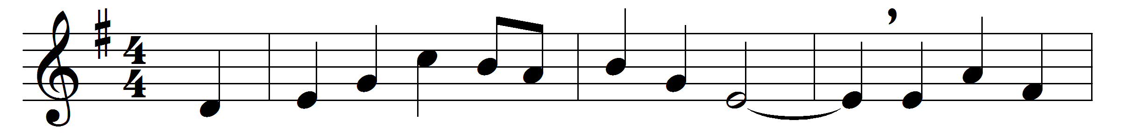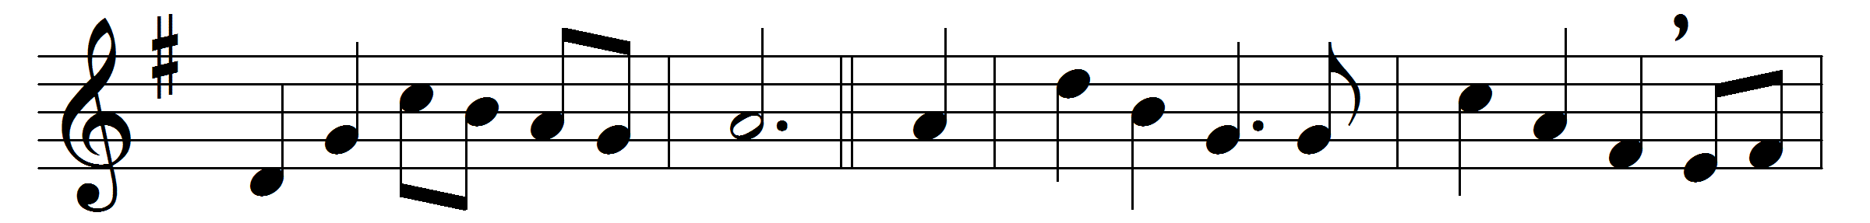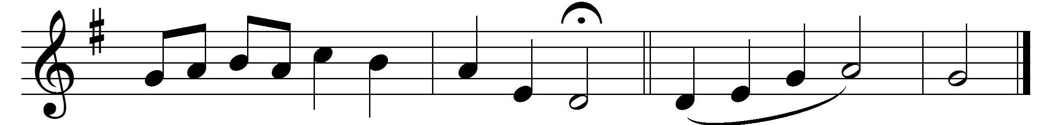

Lord Christ, who on thy heart didst bear
the burden of our shame and sin,
and now on high dost stoop to share
the fight without, the fear within;
thy patience cannot know defeat,
thy pity will not be denied,
thy loving-kindness still is great,
thy tender mercies still abide.
O brother Man, for this we pray,
thou brother Man and sovereign Lord,
that we thy brethren, day by day,
may follow thee and keep thy word;
that we may care, as thou hast cared,
for sick and lame, for deaf and blind,
and freely share, as thou hast shared,
in all the sorrows of mankind;
that ours may be the holy task
to help and bless, to heal and save;
this is the happiness we ask,
and this the service that we crave. Amen.

Words: Arnold Thomas (1848-1924)
Music: Percy Carter Buck (1871-1947)

