Jesus, my Lord, how rich thy grace AMNS 381 Melody: St. Etheldreda C.M.
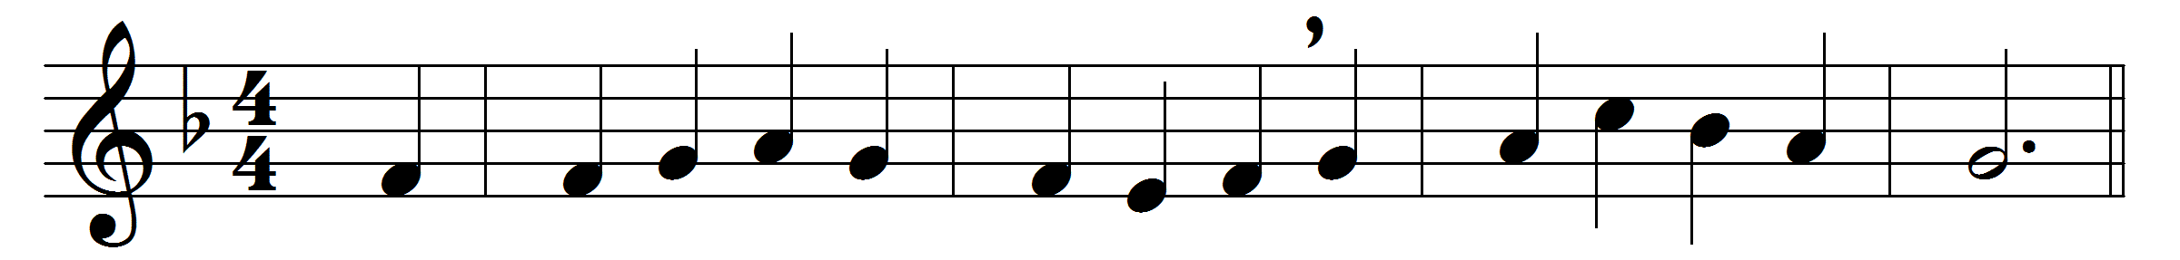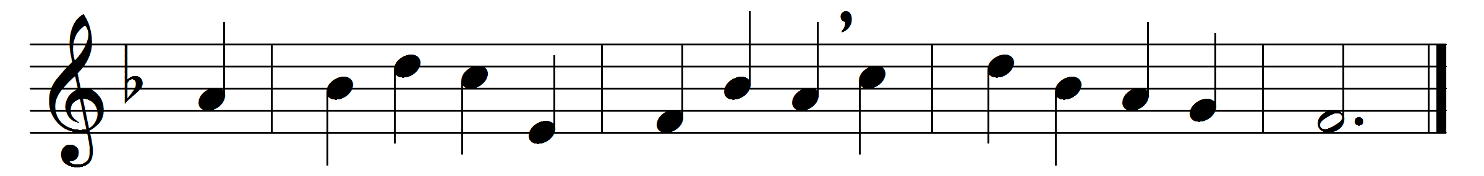

Jesus, my Lord, how rich thy grace,
how fair thy bounties shine!
what can my poverty bestow,
when all the worlds are thine?
But thou hast needy brethren here,
the partners of thy grace,
and wilt confess their humble names
before thy Father’s face.
In them thou may’st be clothed and fed,
and visited and cheered,
and in their accents of distress
the Saviour’s voice is heard.
Thy face with reverence and with love
I in thy poor would see;
O let me rather beg my bread,
than hold it back from thee.

Words: Philip Doddridge (1702-1751)
Music: Thomas Turton (1780-1864)

