While shepherds watched their flocks by night AMNS 37 Melody: Winchester Old C.M.
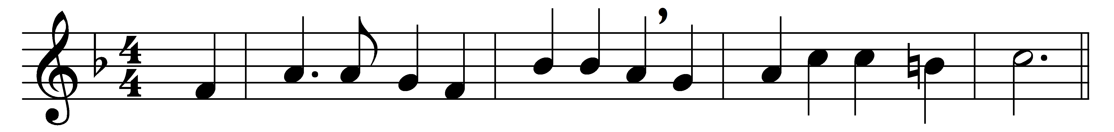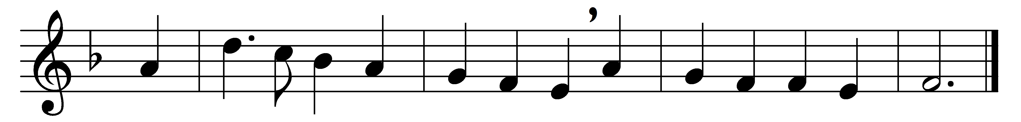

While shepherds watched their flocks by night,
all seated on the ground,
the angel of the Lord came down,
and glory shone around.

‘Fear not,’ said he (for mighty dread
had seized their troubled mind);
‘glad tidings of great joy I bring
to you and all mankind.

‘To you in David’s town this day
is born of David’s line
a Saviour, who is Christ the Lord;
and this shall be the sign:

‘the heavenly babe you there shall find
to human view displayed,
all meanly wrapped in swathing bands,
and in a manger laid.’

Thus spake the seraph; and forthwith
appeared a shining throng
of angels praising God, who thus
addressed their joyful song:

‘All glory be to God on high,
and to the earth be peace;
good will henceforth from heaven to men
begin and never cease.’

Words: Nahum Tate (1652-1715)
Music: Melody from T. Este (Psalms, 1592)

