In Christ there is no east or west AMNS 376 Melody: Kilmarnock C.M.
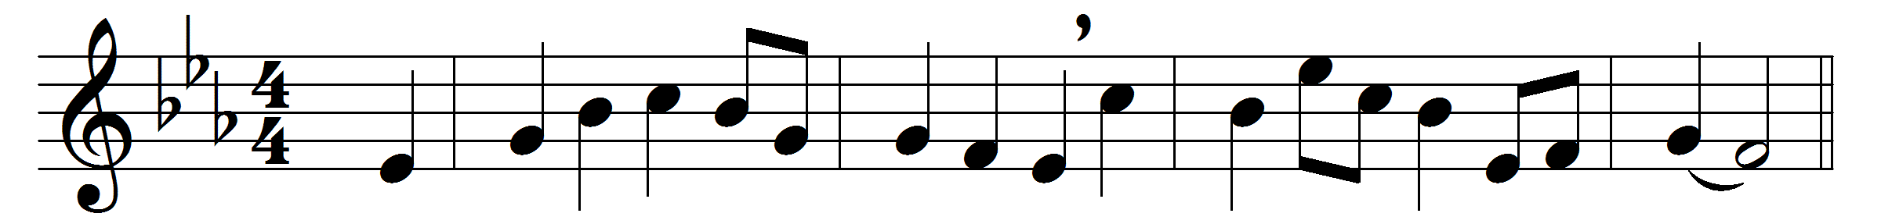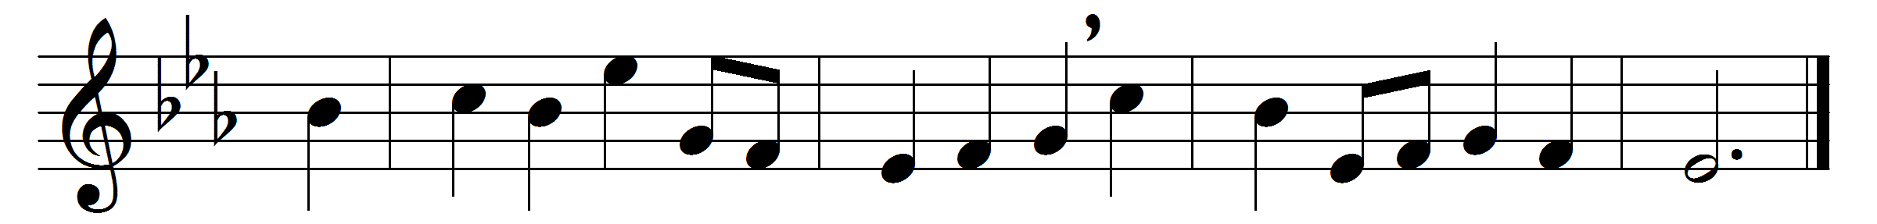

In Christ there is no east or west,
in him no south or north,
but one great fellowship of love
throughout the whole wide earth.
In him shall true hearts everywhere
their high communion find;
his service is the golden cord,
close binding all mankind.
Join hands, then, brothers of the faith,
whate’er your race may be;
who serves my Father as a son
is surely kin to me.
In Christ now meet both east and west,
in him meet south and north;
all Christlike souls are one in him,
throughout the whole wide earth.

Words: John Oxenham (1852-1941)
Music: Melody by Neil Dougall (1776-1862)

