God is Love: let heaven adore him AMNS 365 Melody: Hyfrydol 8 7. 8 7. D.
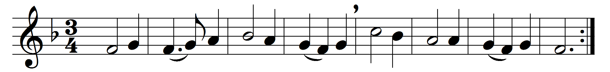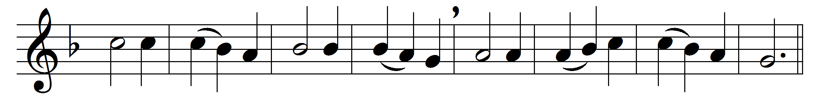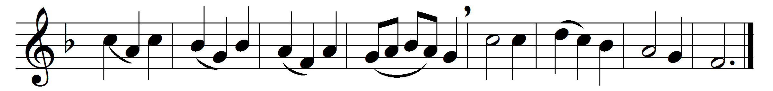

God is Love: let heaven adore him;
God is Love: let earth rejoice;
let creation sing before him,
and exalt him with one voice.
He who laid the earth’s foundation,
he who spread the heavens above,
he who breathes through all creation,
he is Love, eternal Love.

God is Love: and he enfoldeth
all the world in one embrace;
with unfailing grasp he holdeth
every child of every race.
And when human hearts are breaking
under sorrow’s iron rod,
then they find that selfsame aching
deep within the heart of God.

God is Love: and though with blindness
sin afflicts the souls of men,
God’s eternal loving-kindness
holds and guides them even then.
Sin and death and hell shall never
o’er us final triumph gain;
God is Love, so Love for ever
o’er the universe must reign.

Words: Timothy Rees (1874-1939)
Music: Melody by Rowland Hugh Prichard (1811-1887)

