Hark, the herald-angels sing AMNS 35 Melody: Mendelssohn 7 7 7 7. D. 7 7.

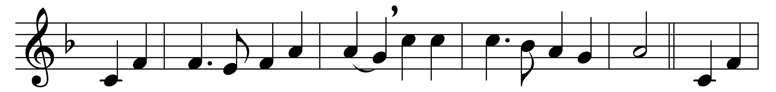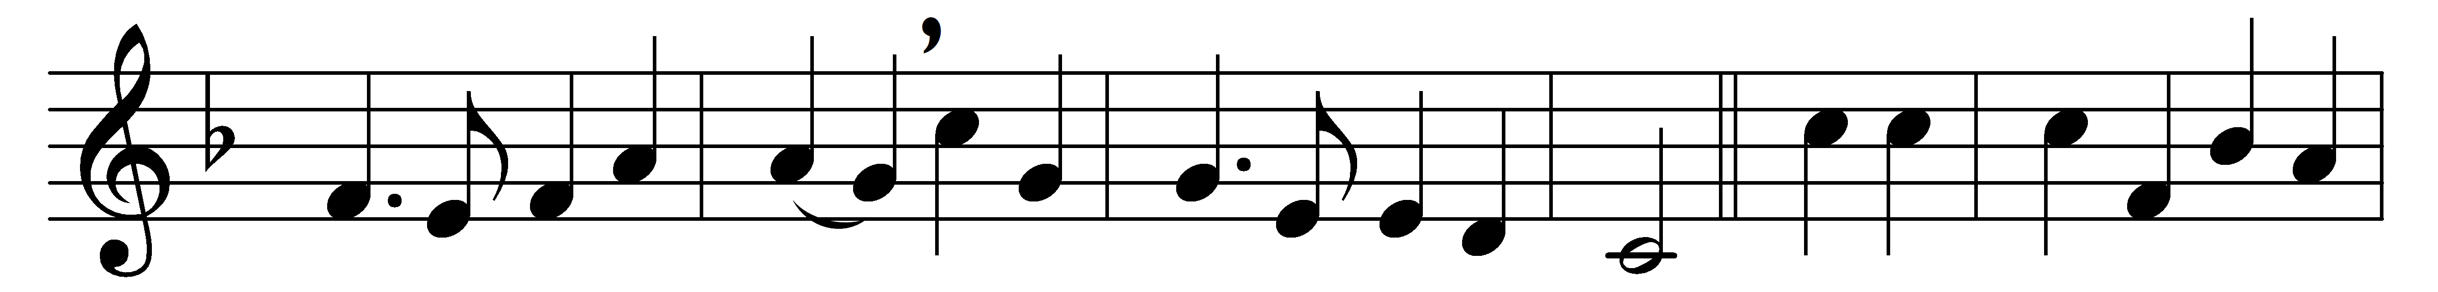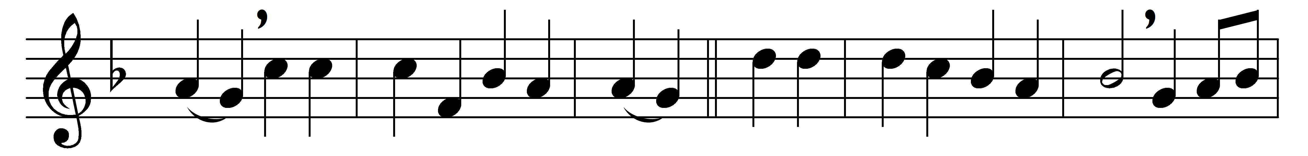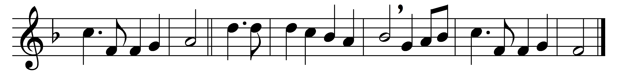

Hark, the herald-angels sing
glory to the new-born King,
peace on earth, and mercy mild,
God and sinners reconciled.
Joyful, all ye nations, rise,
join the triumph of the skies;
with the angelic host proclaim,
‘Christ is born in Bethlehem.’
Hark, the herald-angels sing
glory to the new-born King.

Christ, by highest heaven adored,
Christ, the everlasting Lord,
late in time behold him come,
offspring of a Virgin’s womb.
Veiled in flesh the Godhead see:
hail, the incarnate Deity,
pleased as Man with man to dwell,
Jesus, our Emmanuel.
Hark, the herald-angels sing
glory to the new-born King.

Hail, the heaven-born Prince of Peace:
hail, the Sun of Righteousness.
Light and life to all he brings,
risen with healing in his wings.
Mild he lays his glory by,
born that man no more may die,
born to raise the sons of earth,
born to give them second birth.
Hark, the herald-angels sing
glory to the new-born King.

Words: Charles Wesley (1707-1788) and others
Music: Adapted from Felix Mendelssohn-Bartholdy (1809-1847) by William Hayman Cummings (1831-1915)

