O come, all ye faithful AMNS 34 Melody: Adeste Fideles Irregular metre
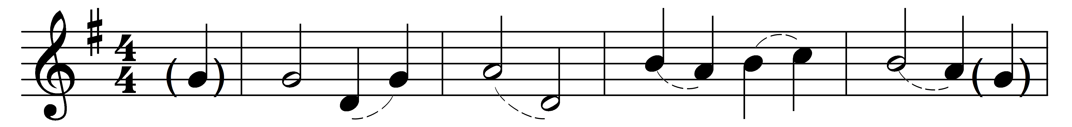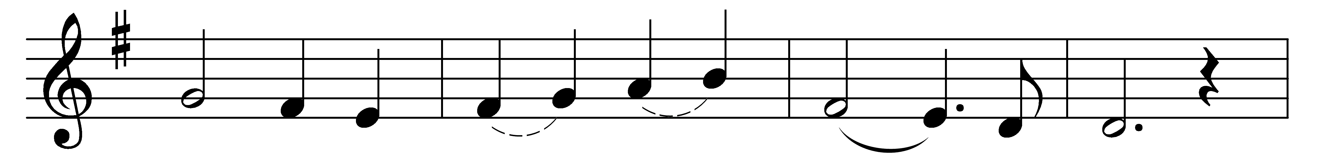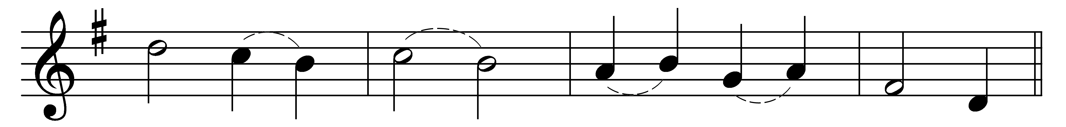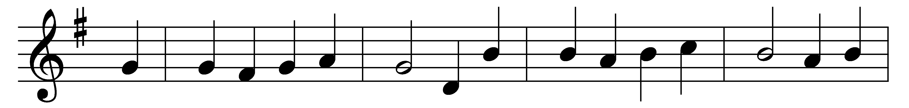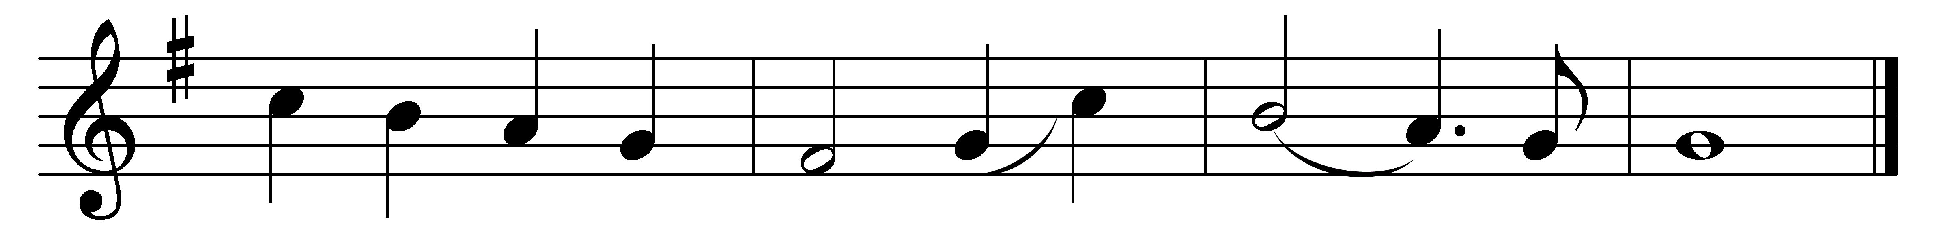

O come, all ye faithful,
joyful and triumphant,
O come ye, O come ye to Bethlehem;
come and behold him
born, the King of angels:
(Refrain:) O come, let us adore him,
O come, let us adore him,
O come, let us adore him, Christ the Lord.
God of God,
Light of Light,
lo, he abhors not the Virgin’s womb;
very God, begotten not created:
(Refrain)

Sing, choirs of angels,
sing in exultation,
sing, all ye citizens of heaven above:
‘Glory to God
in the highest:’
(Refrain)

Yea, Lord, we greet thee,
born this happy morning;
Jesu, to thee be glory given;
Word of the Father,
now in flesh appearing:
(Refrain)

Words: Latin, 18th century, translated by Frederick Oakeley (1802-1880)
Music: Probably by John Francis Wade (c. 1711-1786)

