Be thou my vision, O Lord of my heart AMNS 343 Melody: Slane 10 11. 11 11.
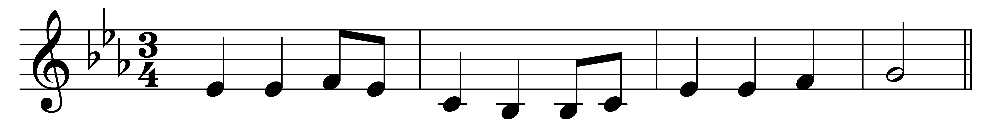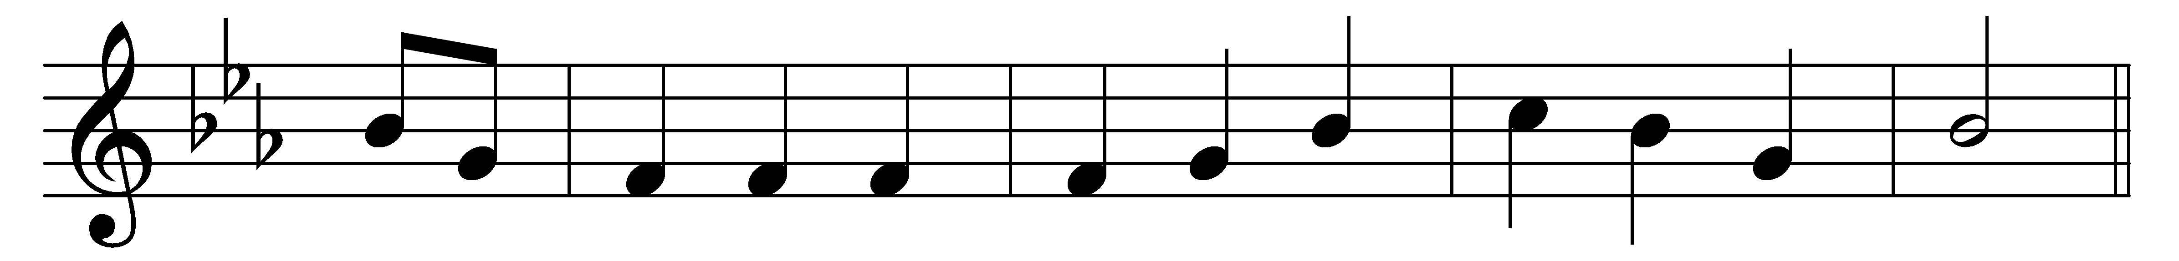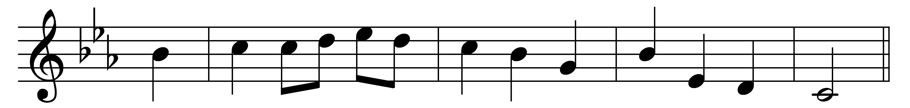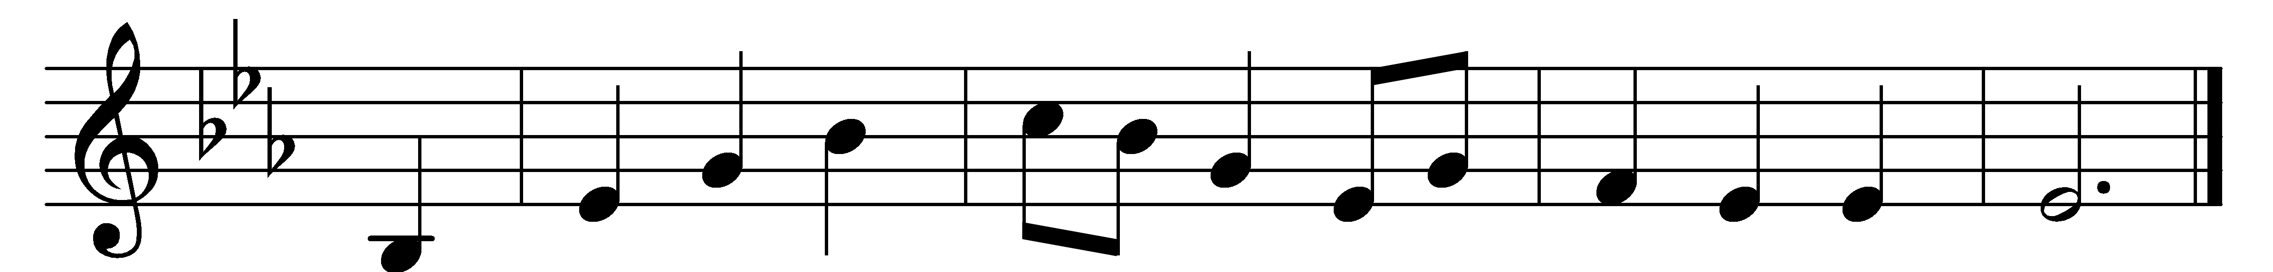

Be thou my vision, O Lord of my heart,
be all else but naught to me, save that thou art;
be thou my best thought in the day and the night,
both waking and sleeping, thy presence my light.

Be thou my wisdom, be thou my true word,
be thou ever with me, and I with thee, Lord;
be thou my great Father, and I thy true son;
be thou in me dwelling, and I with thee one.

Be thou my breastplate, my sword for the fight;
be thou my whole armour, be thou my true might;
be thou my soul’s shelter, be thou my strong tower:
O raise thou me heavenward, great Power of my power.

Riches I heed not, nor man’s empty praise:
be thou mine inheritance now and always;
be thou and thou only the first in my heart;
O Sovereign of heaven, my treasure thou art.

High King of heaven, thou heaven’s bright Sun,
O grant me its joys after victory is won;
great Heart of my own heart, whatever befall,
still be thou my vision, O Ruler of all.

Words: Irish, c. 8th century, translated by Mary Byrne (1880-1931) and versified by Eleanor Hull (1860-1935)
Music: Irish traditional melody

