Of the Father’s love begotten AMNS 33 Melody: Corde natus (Divinum Mysterium) 8 7. 8 7. 8 7. 7.
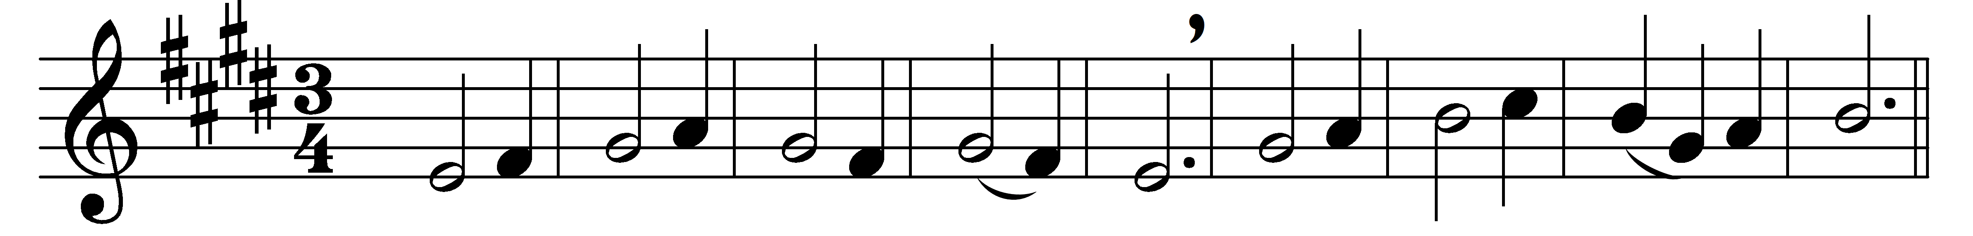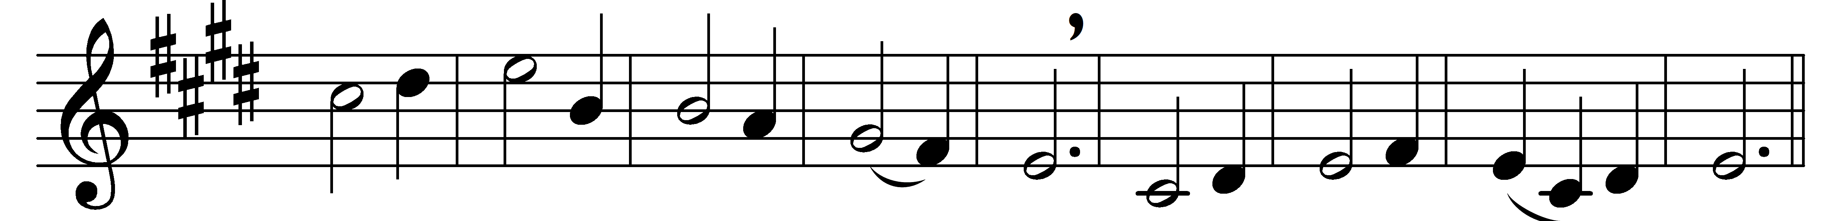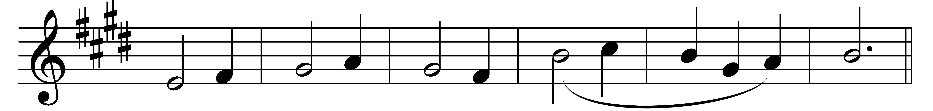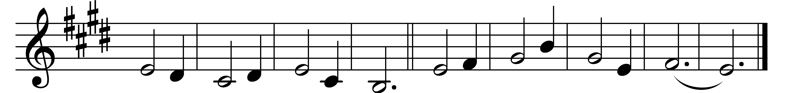

Of the Father’s love begotten
ere the worlds began to be,
he is Alpha and Omega,
he the source, the ending he,
of the things that are, that have been,
and that future years shall see,
evermore and evermore.

O that birth for ever blessèd,
when the Virgin, full of grace,
by the Holy Ghost conceiving,
bare the Saviour of our race,
and the babe, the world’s Redeemer,
first revealed his sacred face,
evermore and evermore.

O ye heights of heaven, adore him;
angel hosts, his praises sing;
powers, dominions bow before him,
and extol our God and King;
let no tongue on earth be silent,
every voice in concert ring,
evermore and evermore.

Words: Prudentius (348-c. 413), translated by John Mason Neale (1818-1866)
Music: Later form of melody in Piae Cantiones, 1582

