A Man there lived in Galilee AMNS 334 Melody: Tyrol D.C.M.
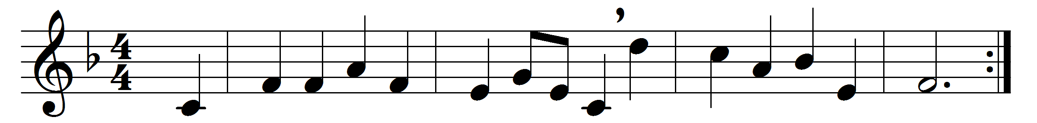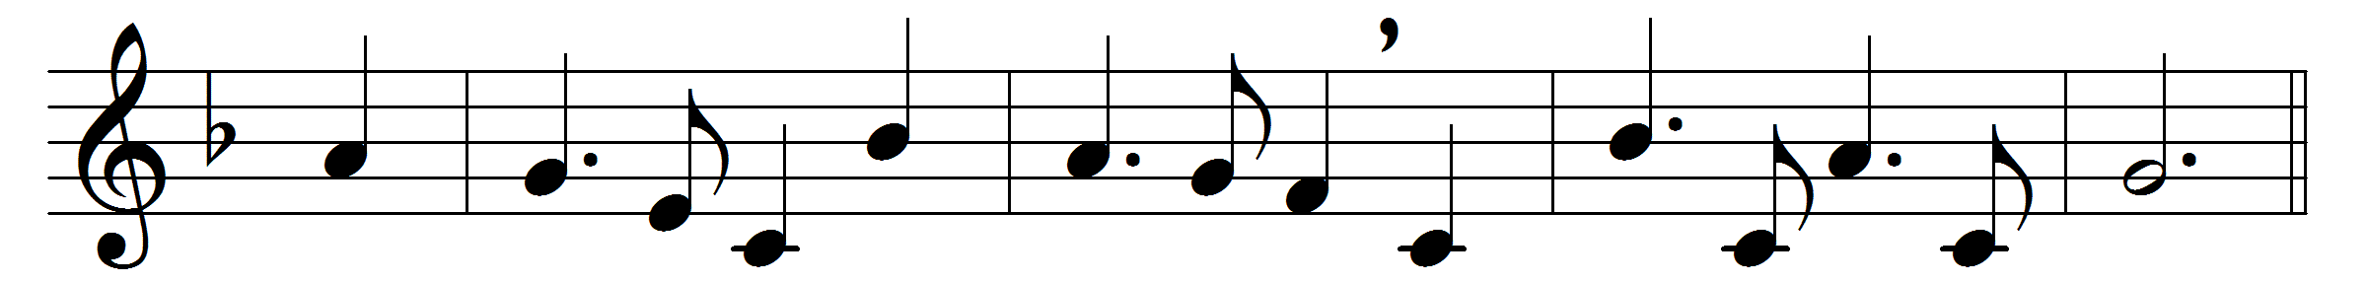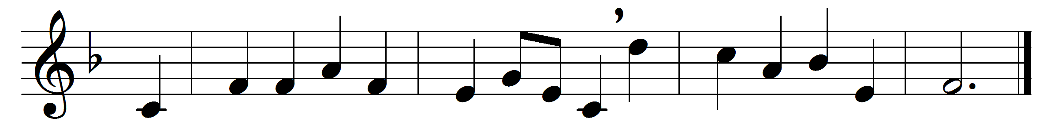

A Man there lived in Galilee
unlike all men before,
for he alone from first to last
our flesh unsullied wore;
a perfect life of perfect deeds
once to the world was shown,
that all mankind might mark his steps
and in them plant their own.
A Man there died on Calvary
above all others brave;
his fellow-men he saved and blessed,
himself he scorned to save.
No thought can gauge the weight of woe
on him, the sinless, laid;
we only know that with his blood
our ransom price was paid.
A Man there reigns in glory now,
divine, yet human still;
that human which is all divine
death sought in vain to kill.
All power is his; supreme he rules
the realms of time and space;
yet still our human cares and needs
find in his heart a place.

Words: Somerset Corry Lowry (1855-1932)
Music: Tyrolean melody

