Onward, Christian soldiers AMNS 333 Melody: St. Gertrude 6 5. 6 5. Ter.
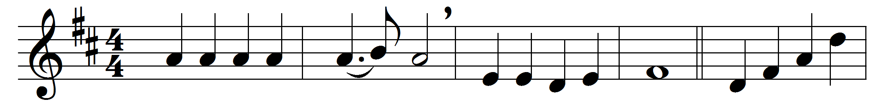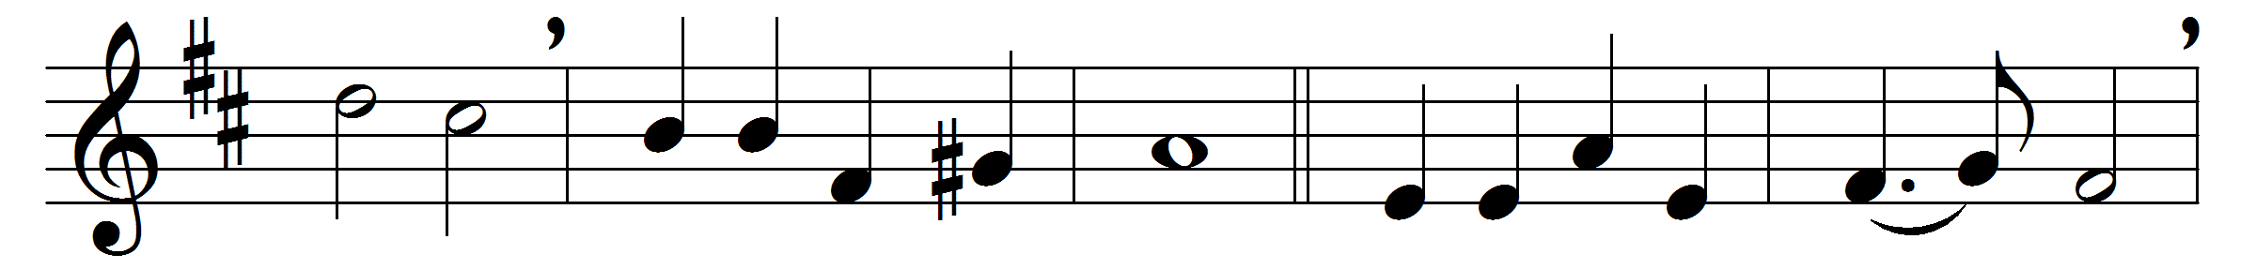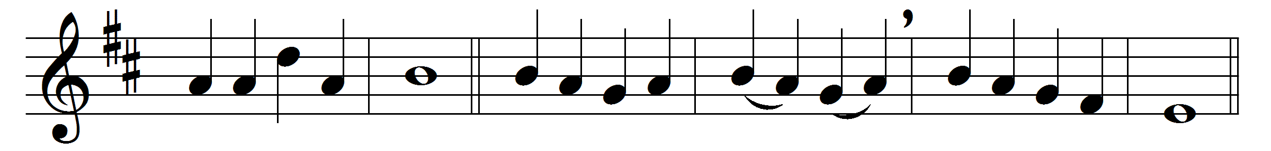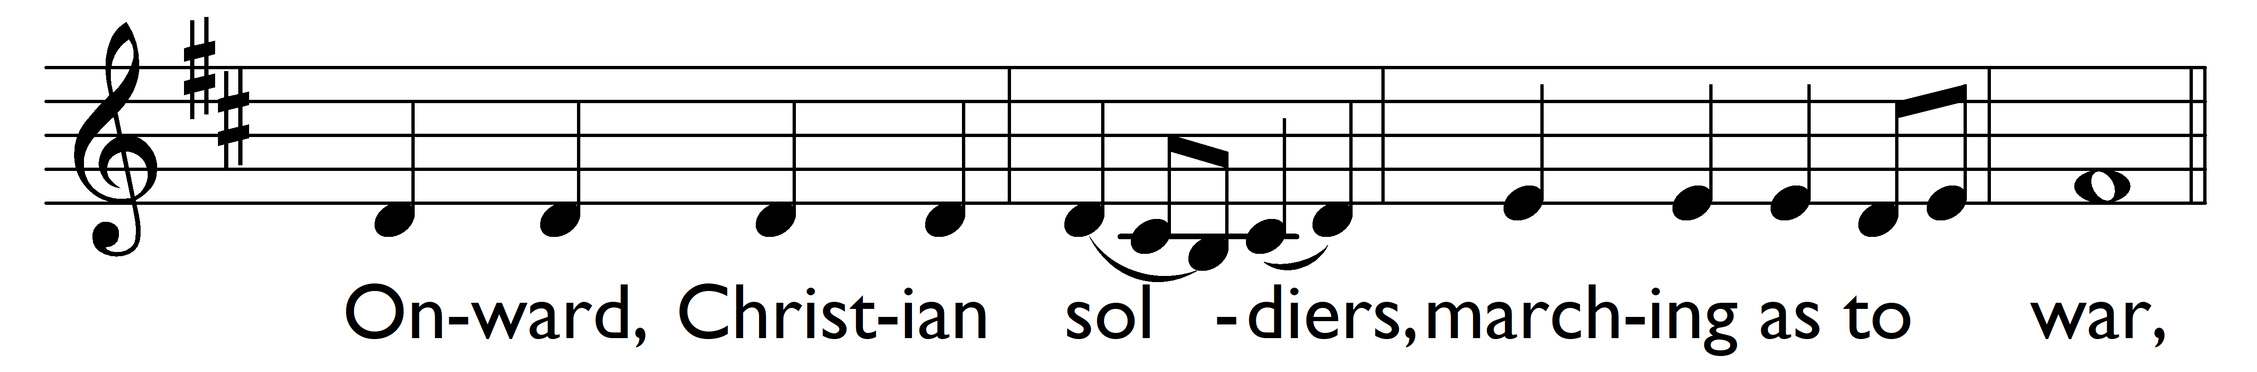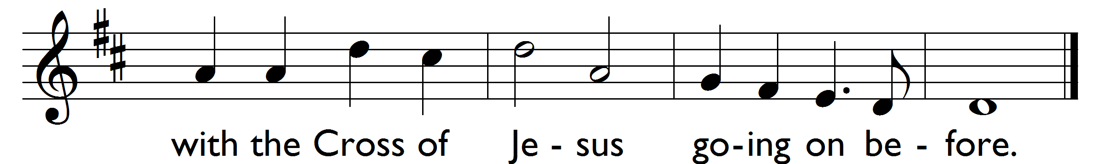

Onward, Christian soldiers, marching as to war,
with the Cross of Jesus going on before.
Christ the royal Master leads against the foe;
forward into battle, see, his banners go:
Refrain: Onward, Christian soldiers, marching as to war,
with the Cross of Jesus going on before.
At the sign of triumph Satan’s host doth flee;
on then, Christian soldiers, on to victory.
Hell’s foundations quiver at the shout of praise;
brothers, lift your voices, loud your anthems raise:
(Refrain)
Like a mighty army moves the Church of God;
brothers, we are treading where the saints have trod:
we are not divided, all one body we,
one in hope and doctrine, one in charity:
(Refrain)
Crowns and thrones may perish, kingdoms rise and wane,
but the Church of Jesus constant will remain:
gates of hell can never ’gainst that Church prevail;
we have Christ’s own promise, and that cannot fail:
(Refrain)
Onward, then, ye people, join our happy throng,
blend with ours your voices in the triumph song:
glory, laud, and honour unto Christ the King,
this through countless ages men and angels sing:
(Refrain)

Words: Sabine Baring-Gould (1834-1924)
Music: Arthur Sullivan (1842-1900)

