To thee our God we fly AMNS 330 Melody: Croft’s 136th 6 6. 6 6. 4 4. 4 4.
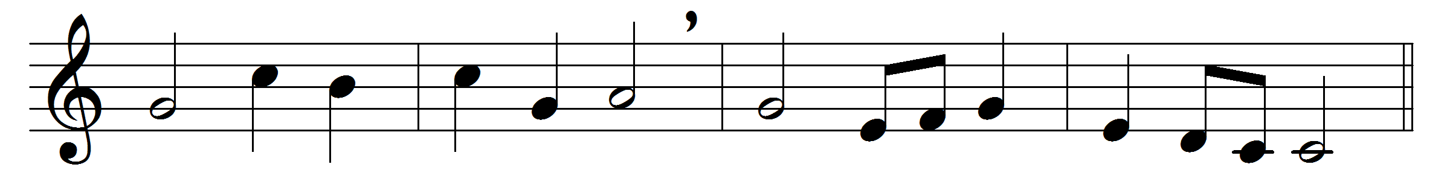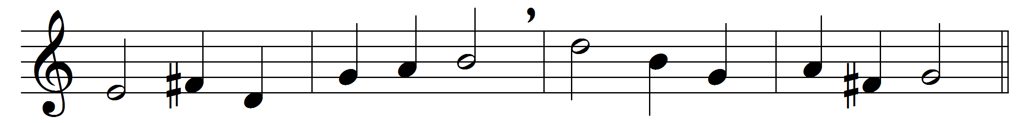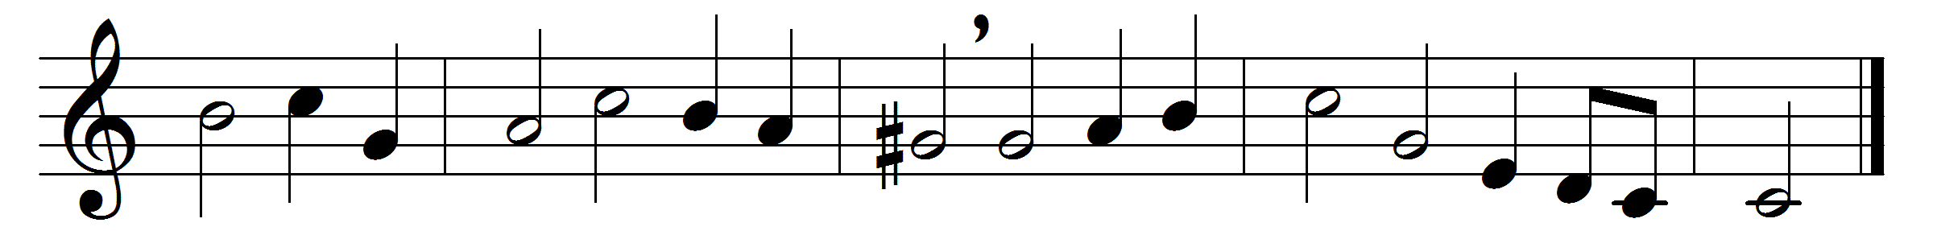

To thee our God we fly
for mercy and for grace;
O hear our lowly cry,
and hide not thou thy face.
O Lord, stretch forth thy mighty hand,
and guard and bless our fatherland.
Arise, O Lord of Hosts,
be jealous for thy name,
and drive from out our coasts
the sins that put to shame:
Thy best gifts from on high
in rich abundance pour,
that we may magnify
and praise thee more and more:
The powers ordained by thee
with heavenly wisdom bless;
may they thy servants be,
and rule in righteousness:
The Church of thy dear Son
inflame with love’s pure fire,
bind her once more in one,
and life and truth inspire:

The pastors of thy fold
with grace and power endue,
that faithful, pure, and bold,
they may be pastors true:
O let us love thy house,
and sanctify thy day,
bring unto thee our vows,
and loyal homage pay:
Give peace, Lord, in our time;
O let no foe draw nigh,
nor lawless deed of crime
insult thy majesty:
Though vile and worthless, still
thy people, Lord, are we;
and for our God we will
none other have but thee.
O Lord, stretch forth thy mighty hand,
and guard and bless our fatherland.
Words: William Walsham How (1823-1897)
Music: Melody and bass by William Croft (1678-1727)

