All glory, laud, and honour AMNS 328 Melody: St. Theodulph 7 6. 7 6. D.
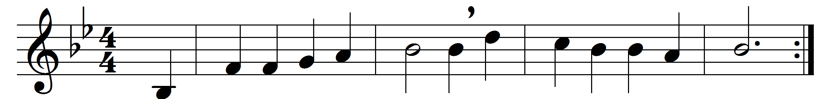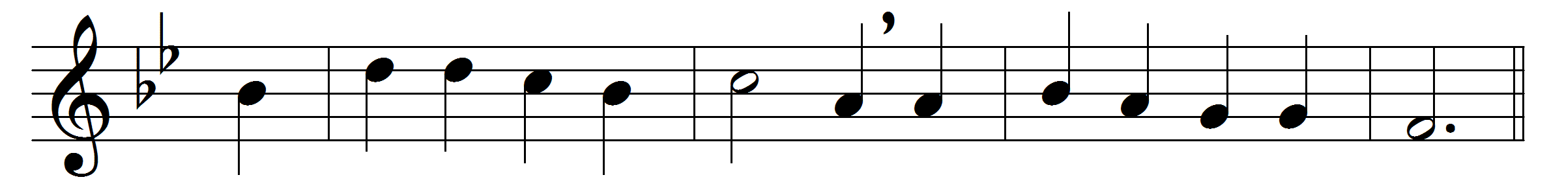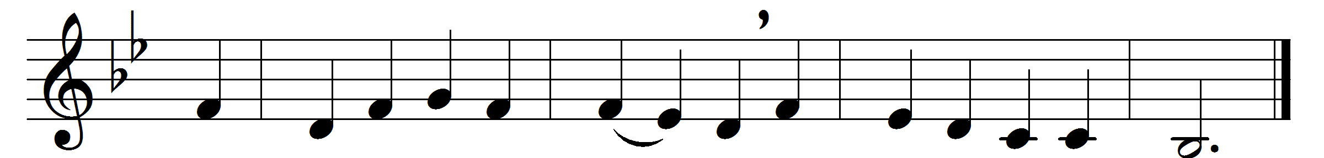

All glory, laud, and honour
to thee, Redeemer, King,
to whom the lips of children
made sweet hosannas ring.

Thou art the King of Israel,
thou David’s royal Son,
who in the Lord’s name comest,
the King and blessèd one:
The company of angels
are praising thee on high,
and mortal men and all things
created make reply:
The people of the Hebrews
with palms before thee went:
our praise and prayer and anthems
before thee we present:
To thee before thy passion
they sang their hymns of praise:
to thee now high exalted
our melody we raise:
Thou didst accept their praises,
accept the prayers we bring,
who in all good delightest,
thou good and gracious King:

Thy sorrow and thy triumph
grant us, O Christ, to share,
that to the holy city
together we may fare:

For homage may we bring thee
our victory o’er the foe,
that in the Conqueror’s triumph
this strain may ever flow:

All glory, laud, and honour
to thee, Redeemer, King,
to whom the lips of children
made sweet hosannas ring.

Words: Theodulph of Orleans (d. 821), translated by John Mason Neale (1818-1866)
Music: Adapted from Melchior Teschner (1584-1635)

