O come, all ye faithful AMNS 326 Melody: Adeste Fideles Irregular metre
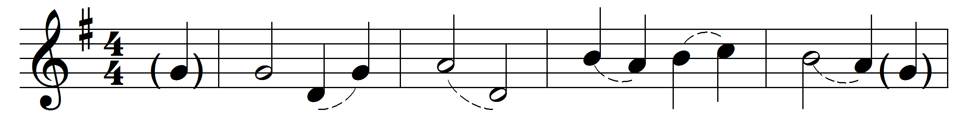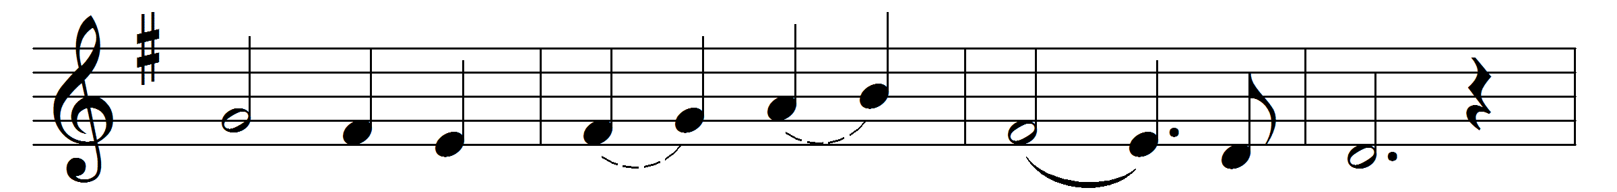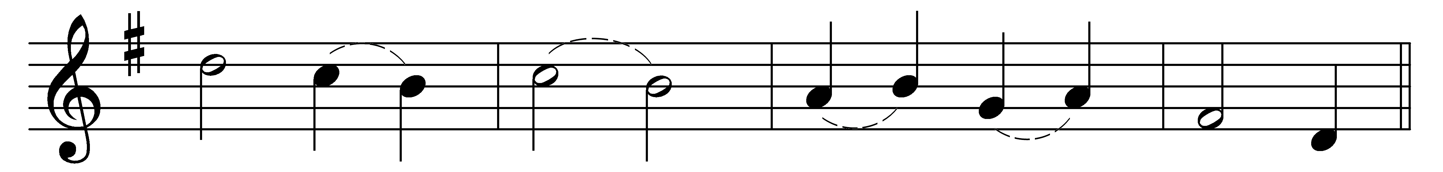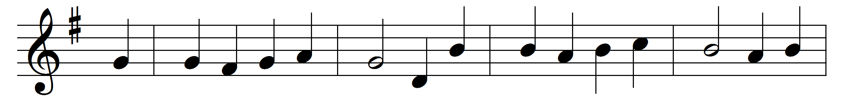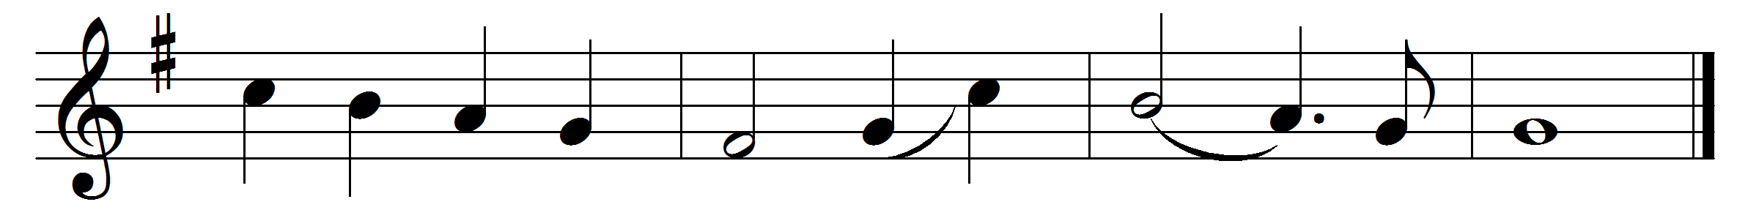

O come, all ye faithful,
joyful and triumphant,
O come ye, O come ye to Bethlehem;
come and behold him
born, the King of angels:
Refrain: O come, let us adore him,
O come, let us adore him,
O come, let us adore him, Christ the Lord.
God of God,
Light of Light,
lo, he abhors not the Virgin’s womb;
very God, begotten not created:
Refrain

See how the shepherds
summoned to his cradle,
leaving their flocks, draw nigh to gaze;
we too will thither
bend our joyful footsteps:
Refrain

Lo, star-led chieftains,
magi, Christ adoring,
offer him incense, gold, and myrrh;
we to the Christ-child
bring our hearts’ oblations:
Refrain
Child, for us sinners
poor and in the manger,
fain we embrace thee with love and awe;
who would not love thee,
loving us so dearly?
Refrain

Sing, choirs of angels,
sing in exultation,
sing, all ye citizens of heaven above:
‘Glory to God
in the highest:’
Refrain

Yea, Lord, we greet thee,
born this happy morning;
Jesu, to thee be glory given;
Word of the Father,
now in flesh appearing:
Refrain

Words: Latin, 18th century, translated by Frederick Oakeley (1802-1880), William Thomas Brooke (1848-1917) and others
Music: Probably by John Francis Wade (c. 1711-1786)

