Give us the wings of faith to rise AMNS 324 Melody: Song 67 C.M.
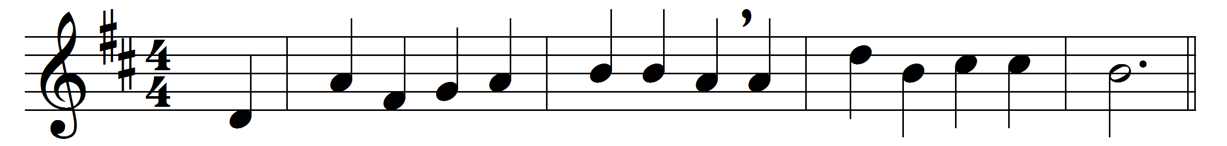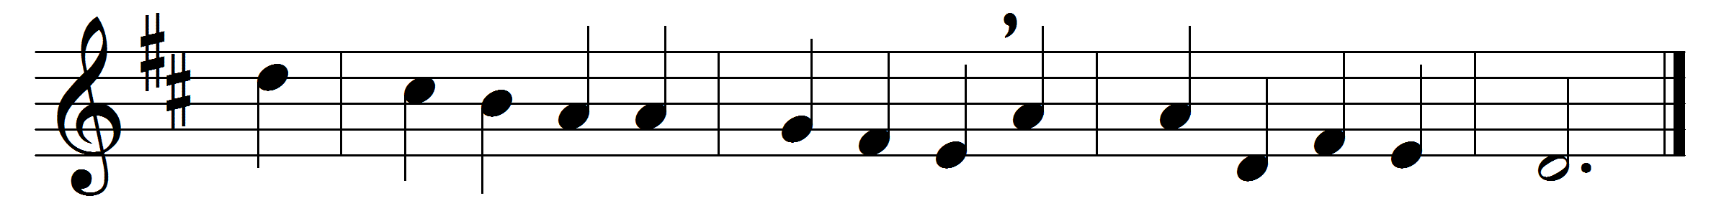

Give us the wings of faith to rise
within the veil, and see
the saints above, how great their joys,
how bright their glories be.

Once they were mourning here below,
their couch was wet with tears;
they wrestled hard, as we do now,
with sins and doubts and fears.

We ask them whence their victory came:
they, with united breath,
ascribe the conquest to the Lamb,
their triumph to his death.

They marked the footsteps that he trod,
his zeal inspired their breast,
and, following their incarnate God,
they reached the promised rest.

Our glorious Leader claims our praise
for his own pattern given;
while the great cloud of witnesses
show the same path to heaven.

Words: Isaac Watts (1674-1748)
Music: Melody and bass by Orlando Gibbons (1583-1625), from Edmund Prys’s Llyfr y Psalmau, 1621

