Around the throne of God a band AMNS 320 Melody: Solothurn L.M.
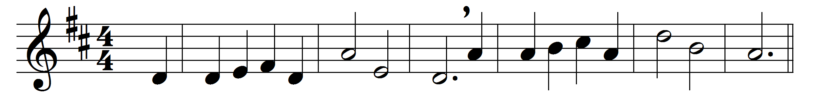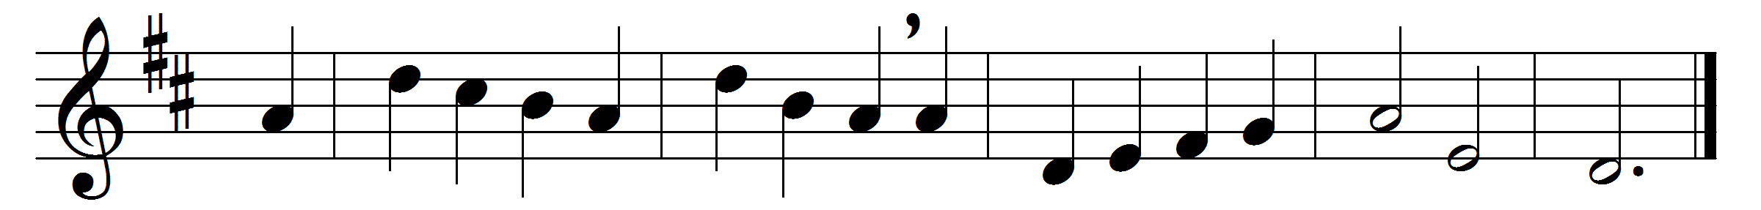

Around the throne of God a band
of glorious angels ever stand;
bright things they see, sweet harps they hold,
and on their heads are crowns of gold.
Some wait around him, ready still
to sing his praise and do his will;
and some, when he commands them, go
to guard his servants here below.
Lord, give thy angels every day
command to guide us on our way,
and bid them every evening keep
their watch around us while we sleep.
So shall no wicked thing draw near,
to do us harm or cause us fear;
and we shall dwell, when life is past,
with angels round thy throne at last.

Words: John Mason Neale (1818-1866)
Music: Swiss traditional melody in Reichart’s Frohe Lieder für deutsche Männer, 1781

