Stars of the morning, so gloriously bright AMNS 319 Melody: Trisagion 10 10. 10 10.
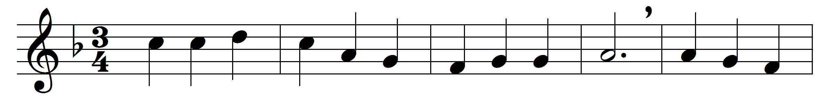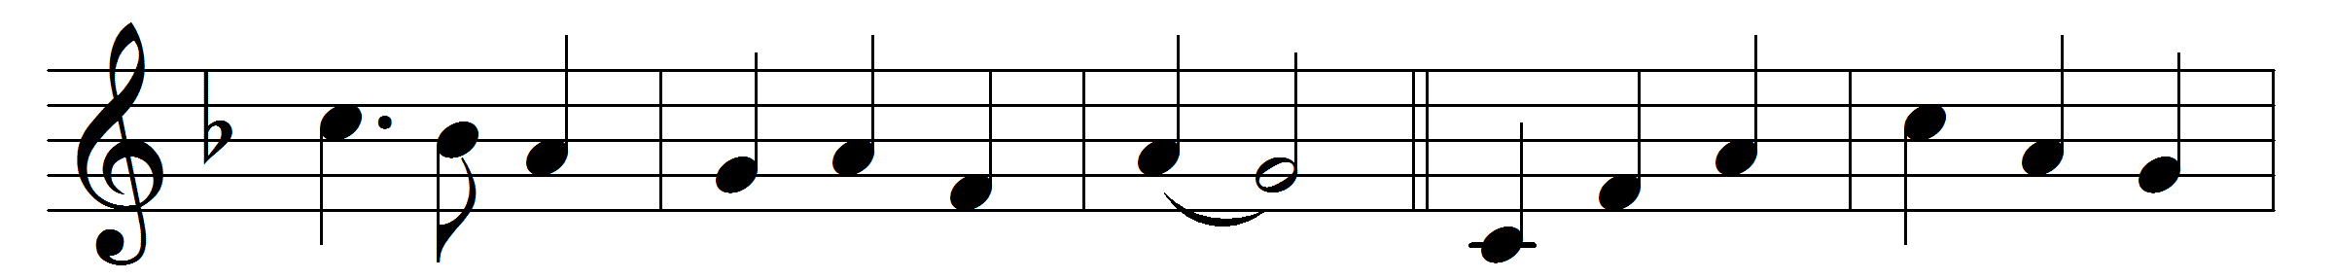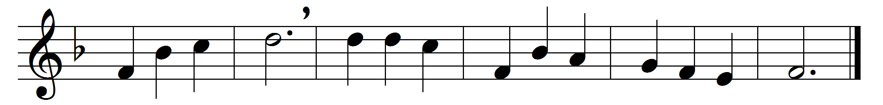

Stars of the morning, so gloriously bright,
filled with celestial virtue and light,
these that, where night never followeth day,
praise the Thrice-Holy for ever and ay:
these are thy ministers, these dost thou own,
Lord God of Sabaoth, nearest thy throne;
these are thy messengers, these dost thou send,
help of the helpless ones, man to defend.
These keep the guard amidst Salem’s dear bowers,
Thrones, Principalities, Virtues, and Powers,
where, with the Living Ones, mystical four,
cherubim, seraphim, bow and adore.
Then, when the earth was first poised in mid space,
then, when the planets first sped on their race,
then, when was ended the six days’ employ,
then all the sons of God shouted for joy.
Still let them succour us; still let them fight,
Lord of angelic hosts, battling for right;
till, where their anthems they ceaselessly pour,
we with the angels may bow and adore.

Words: St. Joseph the Hymnographer (d. 883), paraphrased by John Mason Neale (1818-1866)
Music: Henry Smart (1813-1879)

