Lo, from the desert homes AMNS 316 Melody: Croft’s 136th 6 6. 6 6. 4 4. 4 4.
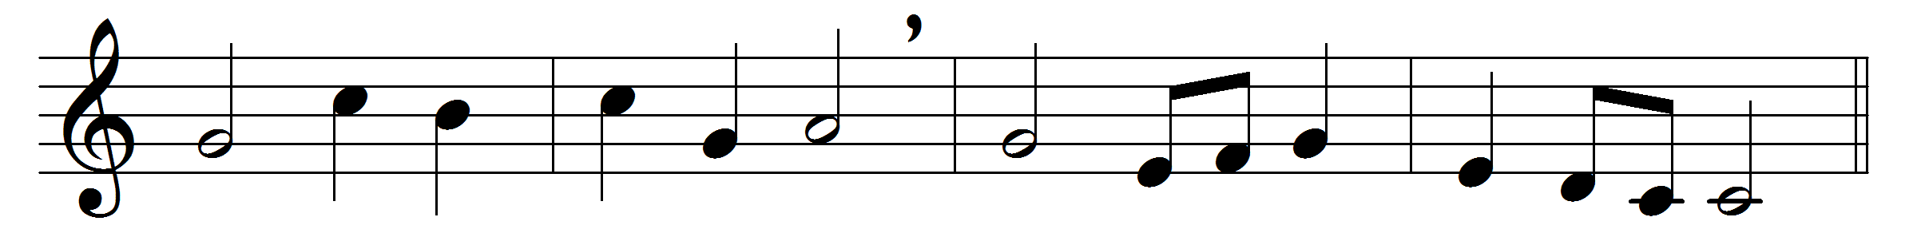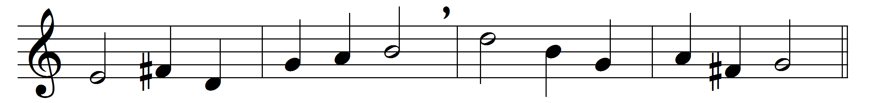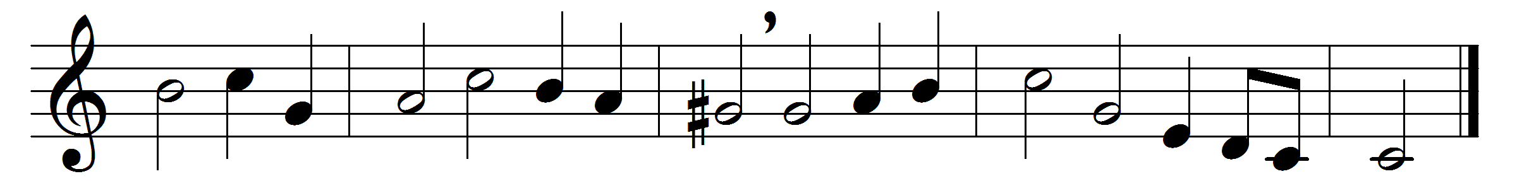

Lo, from the desert homes,
where he hath hid so long,
the new Elijah comes,
in sternest wisdom strong:
the voice that cries
of Christ from high,
and judgement nigh
from opening skies.
Your God e’en now doth stand
at heaven’s opening door;
his fan is in his hand,
and he will purge his floor;
the wheat he claims
and with him stows,
the chaff he throws
to quenchless flames.
Ye haughty mountains, bow
your sky-aspiring heads;
ye valleys, hiding low,
lift up your gentle meads;
make his way plain
your King before,
for evermore
he comes to reign.
May thy dread voice around,
thou harbinger of Light,
on our dull ears still sound,
lest here we sleep in night,
till judgement come,
and on our path
the Lamb’s dread wrath
shall burst in doom.
O God, with love’s sweet might,
who dost anoint and arm
Christ’s soldier for the fight
with grace that shields from harm:
thrice blessèd Three,
heaven’s endless days
shall sing thy praise
eternally.

Words: Charles Coffin (1676-1749), translated by Isaac Williams (1802-1865)
Music: Melody and bass by William Croft (1678-1727)

