The God whom earth and sea and sky AMNS 309 Melody: Puer Nobis Nascitur L.M.
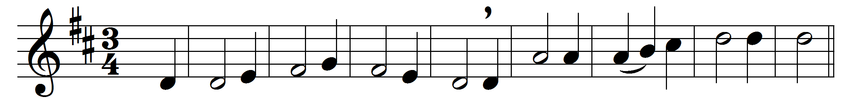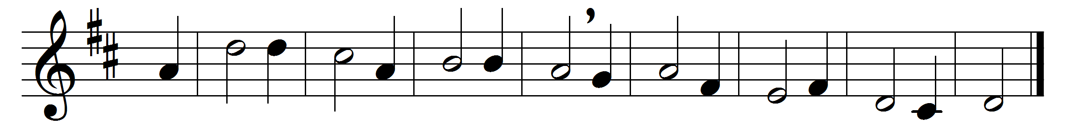

The God whom earth and sea and sky
adore and laud and magnify,
whose might they own, whose praise they tell,
in Mary’s body deigned to dwell.

O Mother blest, the chosen shrine
wherein the Architect divine,
whose hand contains the earth and sky,
vouchsafed in hidden guise to lie:

blest in the message Gabriel brought;
blest in the work the Spirit wrought;
most blest, to bring to human birth
the long Desired of all the earth.

O Lord, the Virgin-born, to thee
eternal praise and glory be,
whom with the Father we adore
and Holy Ghost for evermore.

Words: Venantius Fortunatus (c. 530-c. 600), translated by John Mason Neale (1818-1866)
Music: Melody by Michael Praetorius (1571-1621)

