For all thy saints, O Lord AMNS 308 Melody: Mount Ephraim S.M.
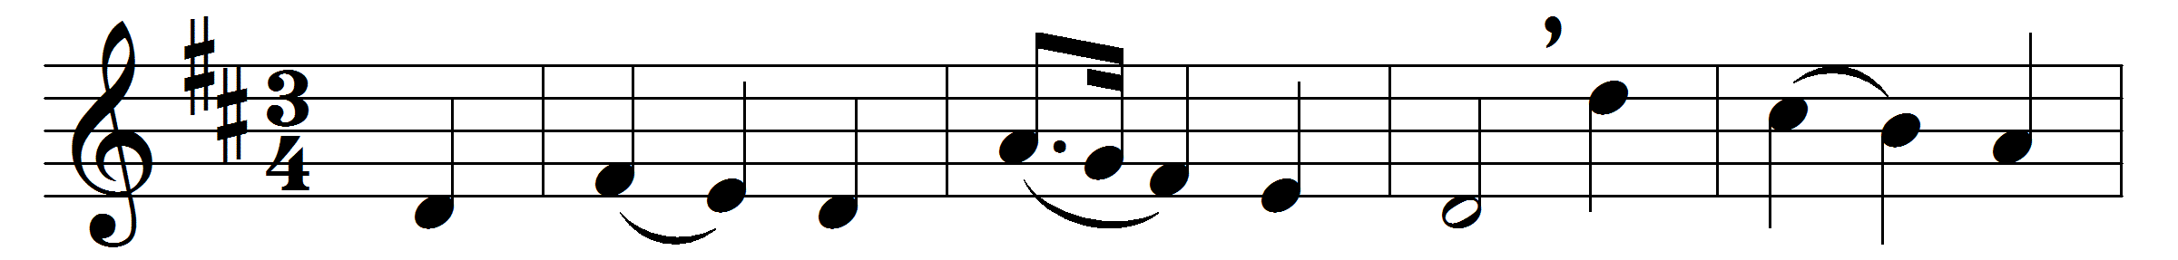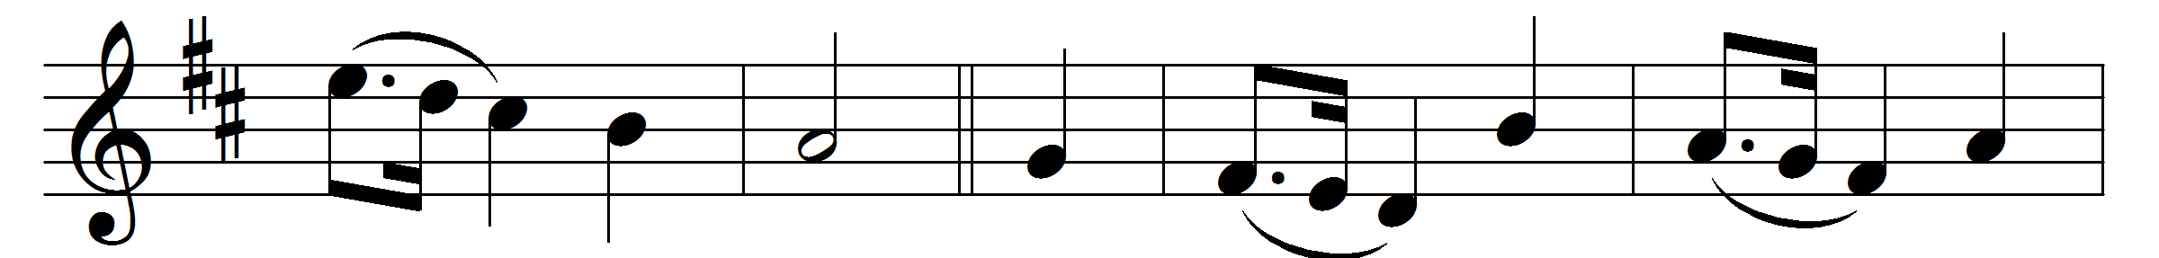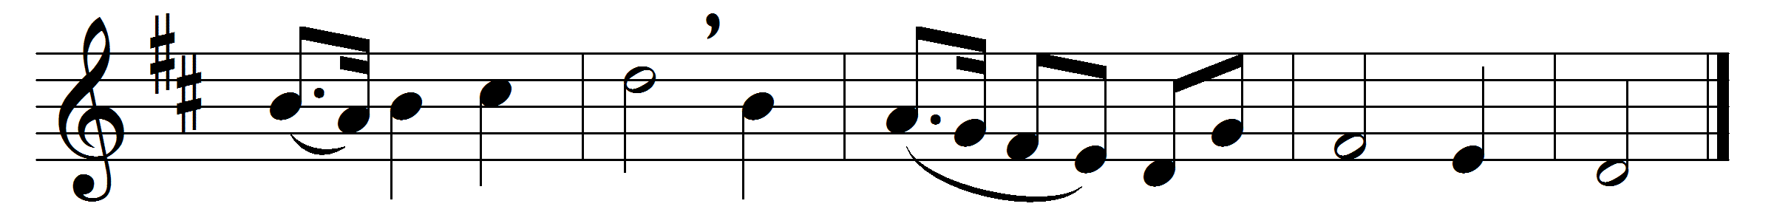

For all thy saints, O Lord,
who strove in thee to live,
who followed thee, obeyed, adored,
our grateful hymn receive.
For all thy saints, O Lord,
who strove in thee to die,
and found in thee a full reward,
accept our thankful cry.
Thine earthly members fit
to join thy saints above,
in one communion ever knit,
one fellowship of love.
Jesu, thy name we bless,
and humbly pray that we
may follow them in holiness,
who lived and died for thee.
All might, all praise, be thine,
Father, co-equal Son,
and Spirit, bond of love divine,
while endless ages run.

Words: Richard Mant (1776-1848)
Music: Melody by Benjamin Milgrove (1731-1810)

