How bright these glorious spirits shine! AMNS 306 Melody: Stracathro C.M.
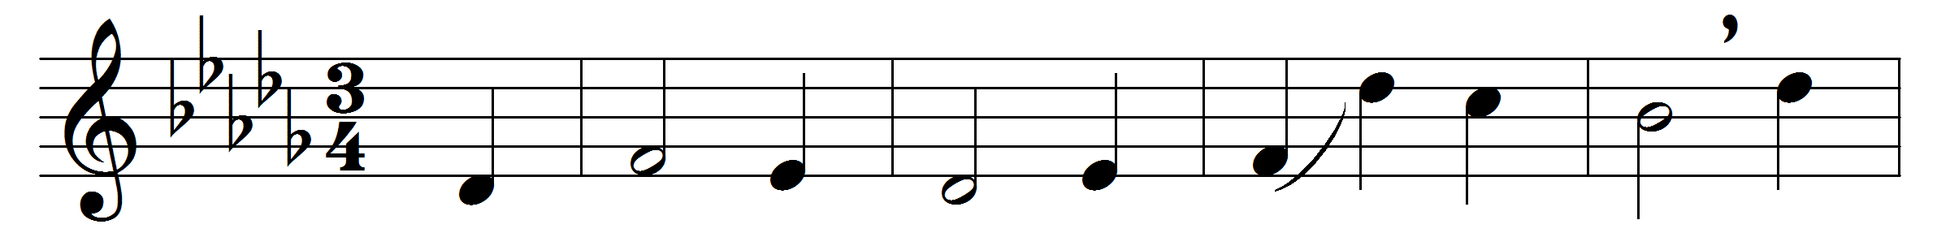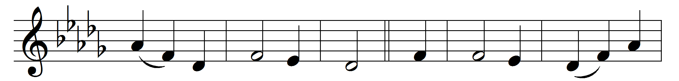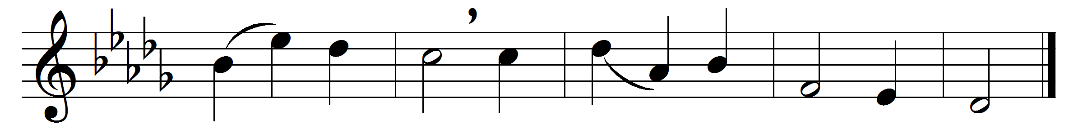

How bright these glorious spirits shine!
whence all their white array?
How came they to the blissful seats
of everlasting day?

Lo, these are they from sufferings great
who came to realms of light;
and in the blood of Christ have washed
those robes that shine so bright.

Now with triumphal palms they stand
before the throne on high,
and serve the God they love amidst
the glories of the sky.

Hunger and thirst are felt no more,
nor suns with scorching ray;
God is their sun, whose cheering beams
diffuse eternal day.

The Lamb, which dwells amidst the throne,
shall o’er them still preside,
feed them with nourishment divine,
and all their footsteps guide.

Midst pastures green he’ll lead his flock,
where living streams appear;
and God the Lord from every eye
shall wipe off every tear.
To Father, Son, and Holy Ghost,
the God whom we adore,
be glory, as it was, is now,
and shall be evermore.
Words: Isaac Watts (1674-1748) and others
Music: Melody by Charles Hutcheson (1792-1860)

