How beauteous are their feet AMNS 301 Melody: Venice S.M.
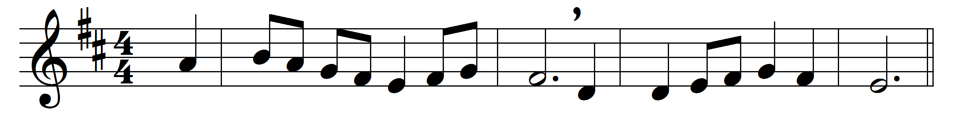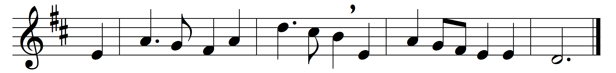

How beauteous are their feet,
who stand on Sion’s hill,
who bring salvation on their tongues
and words of peace instil.

How happy are our ears
that hear this happy sound,
which kings and prophets waited for,
and sought, but never found.

How blessèd are our eyes
that see this heavenly light:
prophets and kings desired it long,
but died without the sight.

The Lord makes bare his arm
through all the earth abroad:
let every nation now behold
their Saviour and their God.

Words: Isaac Watts (1674-1748)
Music: William Amps (1824-1910)

