Come, pure hearts, in sweetest measures AMNS 300
Melody: Evangelists (Alles ist an Gottes Segen) 8 8 7. D.
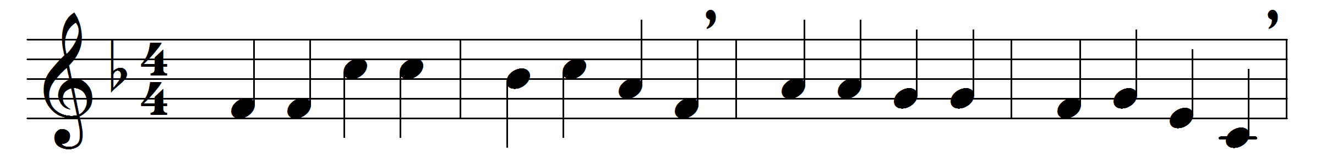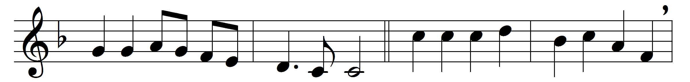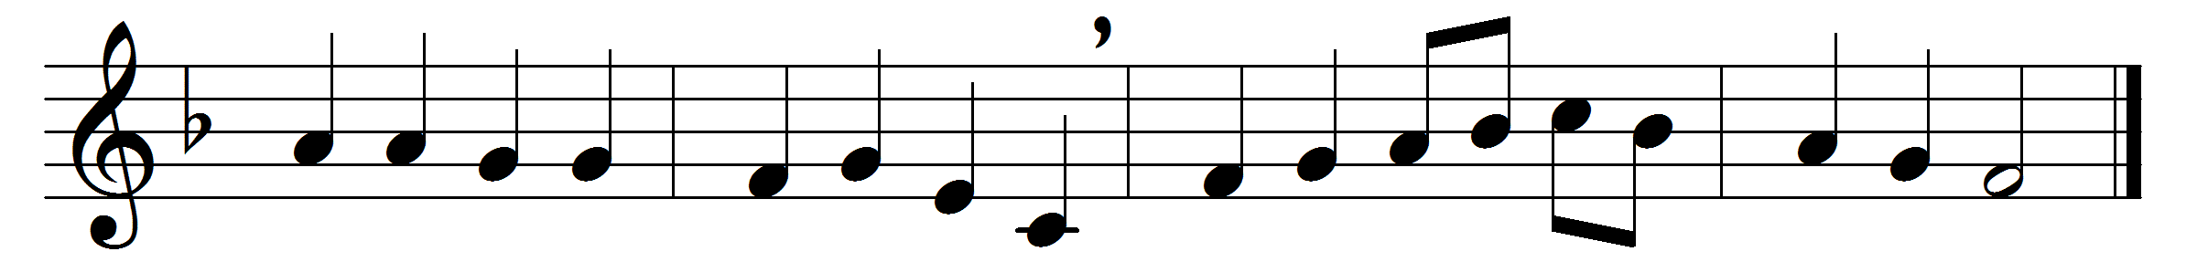

Come, pure hearts, in sweetest measures
sing of those who spread the treasures
in the holy gospels shrined:
blessèd tidings of salvation,
peace on earth, their proclamation,
love from God to lost mankind.
Thou, by whom the words were given
for our light and guide to heaven,
Spirit, on our darkness shine;
graft them in our hearts, increasing
faith, hope, love, and joy unceasing,
till our hearts are wholly thine.
O that we, thy truth confessing
and thy holy word possessing,
Jesu, may thy love adore;
unto thee our voices raising,
thee with all thy ransomed praising,
ever and for evermore.

Words: Robert Campbell (1814-1868) and others
Music: Adapted from Johann Sebastian Bach’s version of a chorale by Johann Löhner and others

