New every morning is the love AMNS 2 Melody: Melcombe L.M.
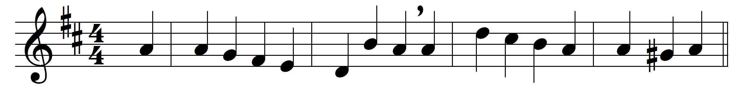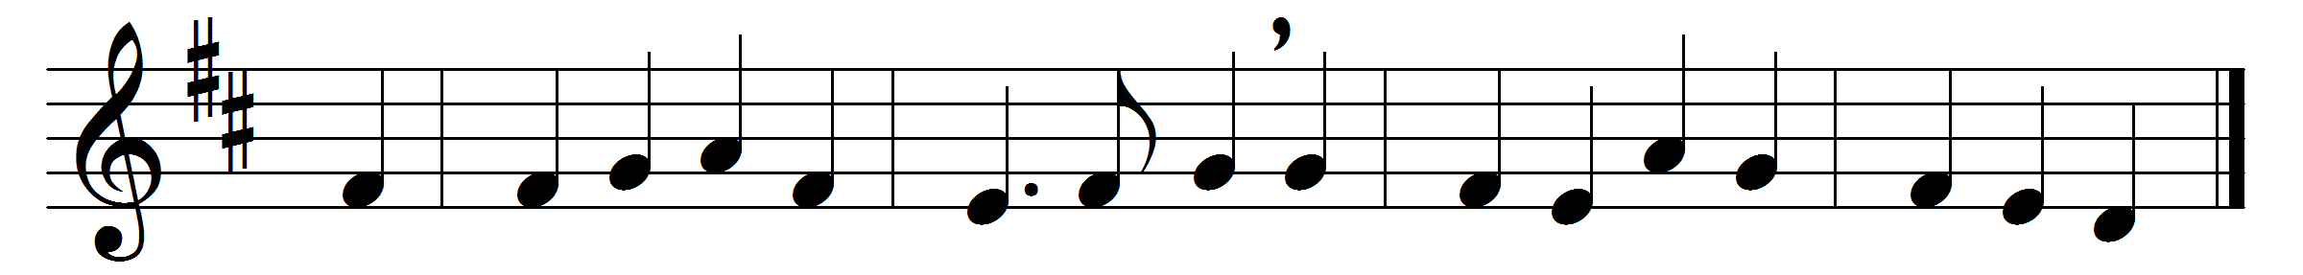

New every morning is the love
our wakening and uprising prove;
through sleep and darkness safely brought,
restored to life and power and thought.

New mercies, each returning day,
hover around us while we pray;
new perils past, new sins forgiven,
new thoughts of God, new hopes of heaven.

If on our daily course our mind
be set to hallow all we find,
new treasures still, of countless price,
God will provide for sacrifice.

The trivial round, the common task,
will furnish all we need to ask,
room to deny ourselves, a road
to bring us daily nearer God.

Only, O Lord, in thy dear love
fit us for perfect rest above;
and help us, this and every day,
to live more nearly as we pray.

Words: John Keble (1792-1866)
Music: Samuel Webbe the elder (1740-1816)

