Disposer supreme, and Judge of the earth AMNS 298 Melody: Hanover 10 10. 11 11.
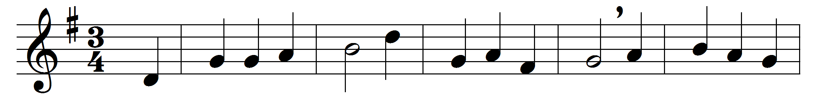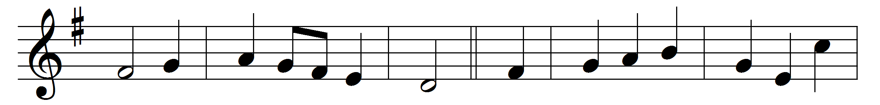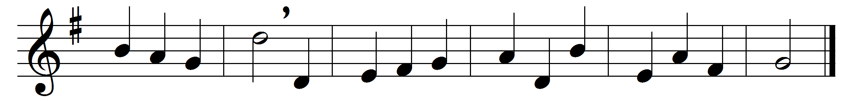

Disposer supreme, and Judge of the earth,
who choosest for thine the meek and the poor;
to frail earthen vessels, and things of no worth,
entrusting thy riches which ay shall endure;

those vessels soon fail, though full of thy light,
and at thy decree are broken and gone;
thence brightly appeareth thy truth in its might,
as through the clouds riven the lightnings have shone.

Like clouds are they borne to do thy great will,
and swift as the winds about the world go:
the Word with his wisdom their spirits doth fill;
they thunder, they lighten, the waters o’erflow.

Their sound goeth forth, ‘Christ Jesus the Lord!’
then Satan doth fear, his citadels fall;
as when the dread trumpets went forth at thy word,
and one long blast shattered the Canaanite’s wall.

O loud be their trump, and stirring their sound,
to rouse us, O Lord, from slumber of sin:
the lights thou hast kindled in darkness around,
O may they awaken our spirits within.

All honour and praise, dominion and might,
to God, Three in One, eternally be,
who round us hath shed his own marvellous light,
and called us from darkness his glory to see.

Words: Jean-Baptiste de Santeuil (1630-1697), translated by Isaac Williams (1802-1865)
Music: Supplement to the New Version, 1708

