The eternal gifts of Christ the King AMNS 297 Melody: Illsley (Bishop) L.M.
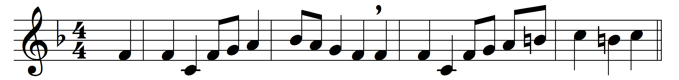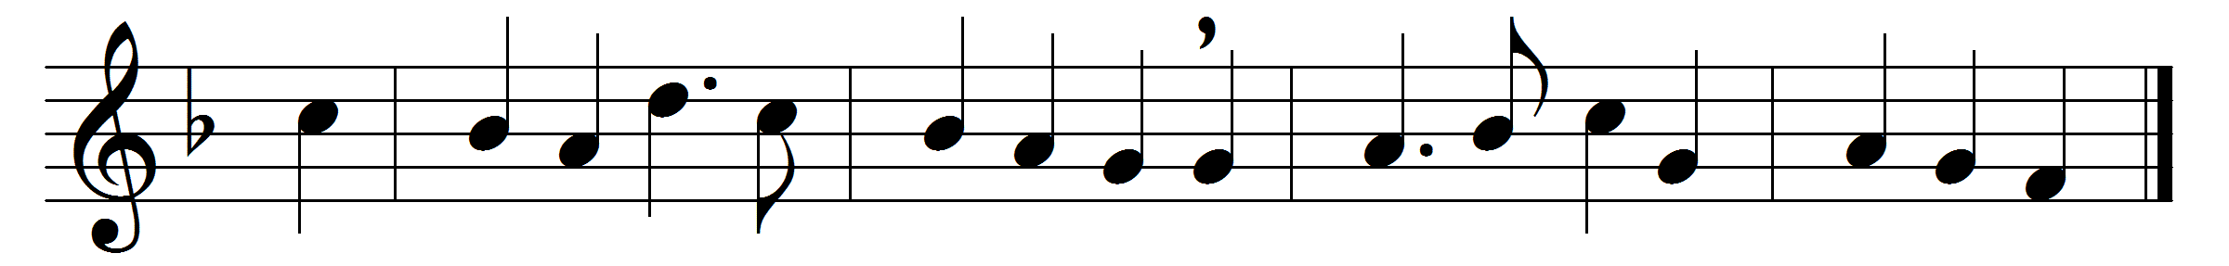

The eternal gifts of Christ the King,
the apostles’ glory, let us sing;
and all, with hearts of gladness, raise
due hymns of thankful love and praise.
For they the Church’s princes are,
triumphant leaders in the war,
in heavenly courts a warrior band,
true lights to lighten every land.
Theirs is the steadfast faith of saints,
and hope that never yields nor faints,
and love of Christ in perfect glow
that lays the prince of this world low.
In them the Father’s glory shone,
in them the will of God the Son,
in them exults the Holy Ghost,
through them rejoice the heavenly host.
To thee, Redeemer, now we cry,
that thou wouldst join to them on high
thy servants, who this grace implore,
for ever and for evermore.

Words: St. Ambrose (c. 340-397), translated by John Mason Neale (1818-1866)
Music: John Bishop (1665-1737)

