And did those feet in ancient time AMNS 294 Melody: Jerusalem D.L.M.
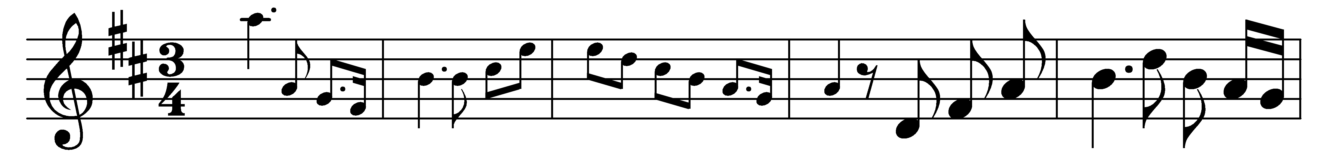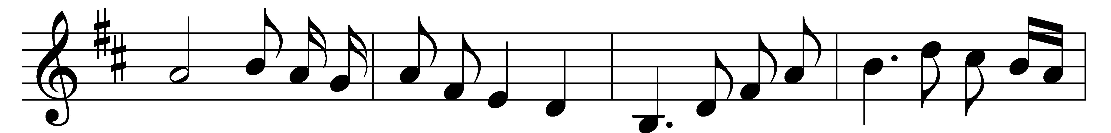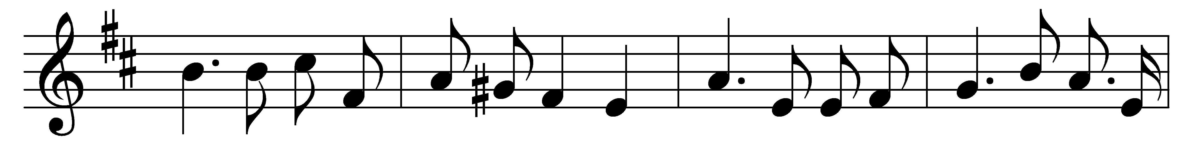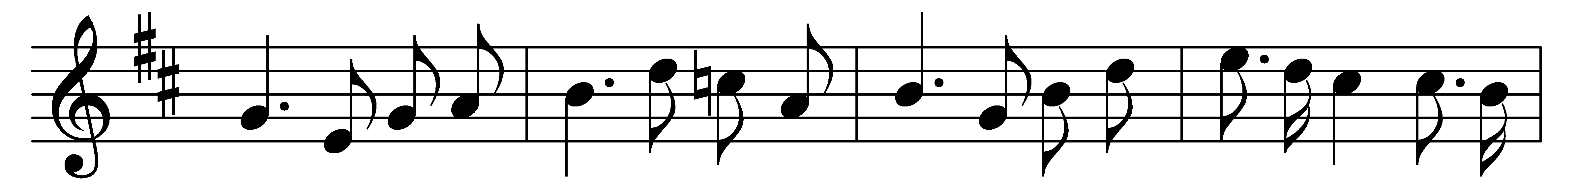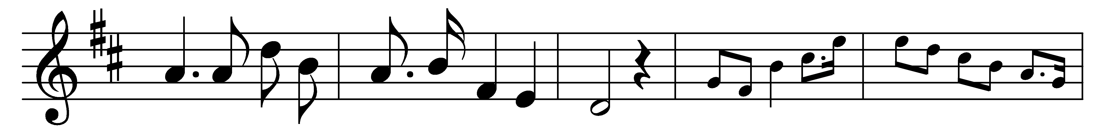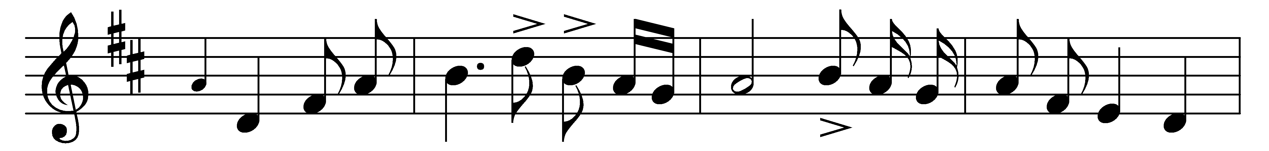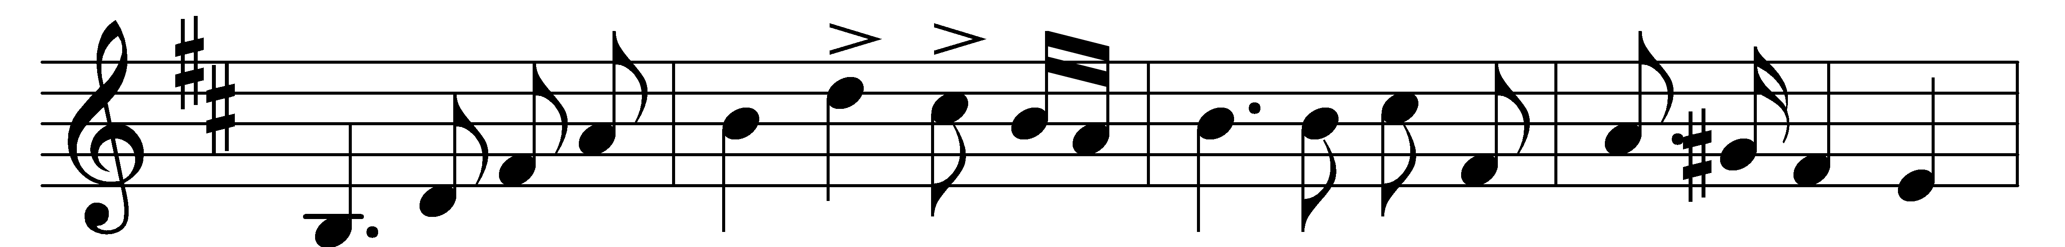
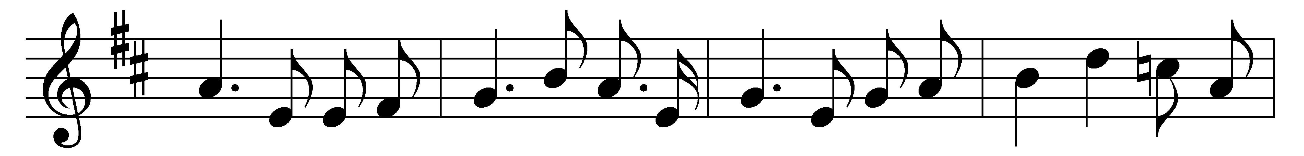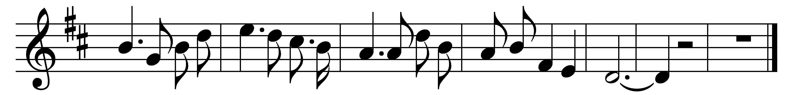

And did those feet in ancient time
walk upon England’s mountains green?
And was the holy Lamb of God
on England’s pleasant pastures seen?
And did the countenance divine
shine forth upon our clouded hills?
And was Jerusalem builded here
among these dark satanic mills?

Bring me my bow of burning gold!
Bring me my arrows of desire!
Bring me my spear! O clouds, unfold!
Bring me my chariot of fire!
I will not cease from mental fight,
nor shall my sword sleep in my hand,
till we have built Jerusalem
in England’s green and pleasant land.

Words: William Blake (1757-1827)
Music: Charles Hubert Hastings Parry (1848-1918)

