God save our gracious King AMNS 293 Melody: National Anthem 6 6 4. 6 6 6 4.
(Alternative version)
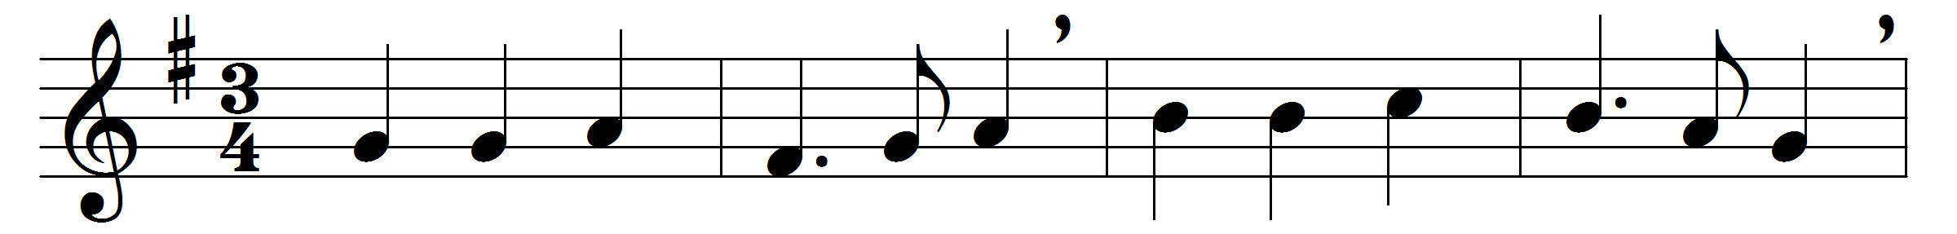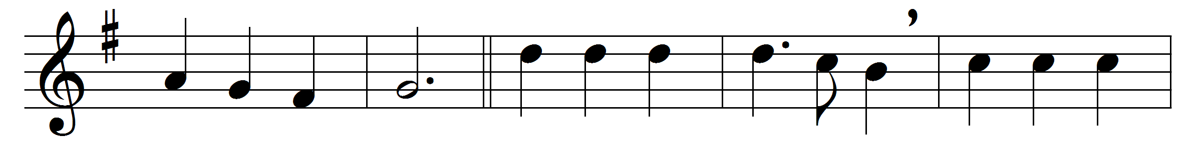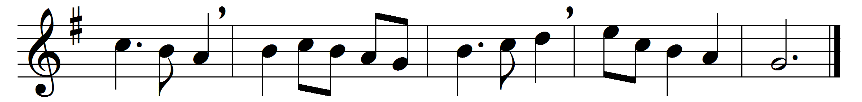

God save our gracious King,
long live our noble King,
God save the King.
Send him victorious,
happy and glorious,
long to reign over us:
God save the King.
Nor on this land alone,
but be God’s mercies known
from shore to shore.
Lord, make the nations see
that all should brothers be
and form one family
the wide world o’er.

Words: v. 1 Anonymous, v. 2 William Edward Hickson (1803-1870)
Music: Thesaurus Musicus, c. 1743

