Praise, O praise our God and King AMNS 288 Melody: Monkland 7 7. 7 7.
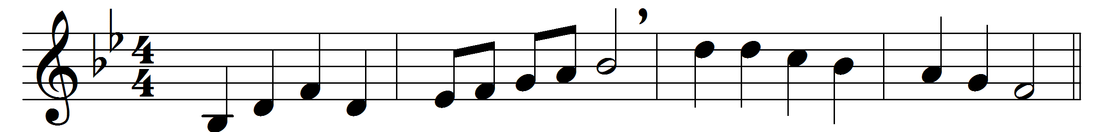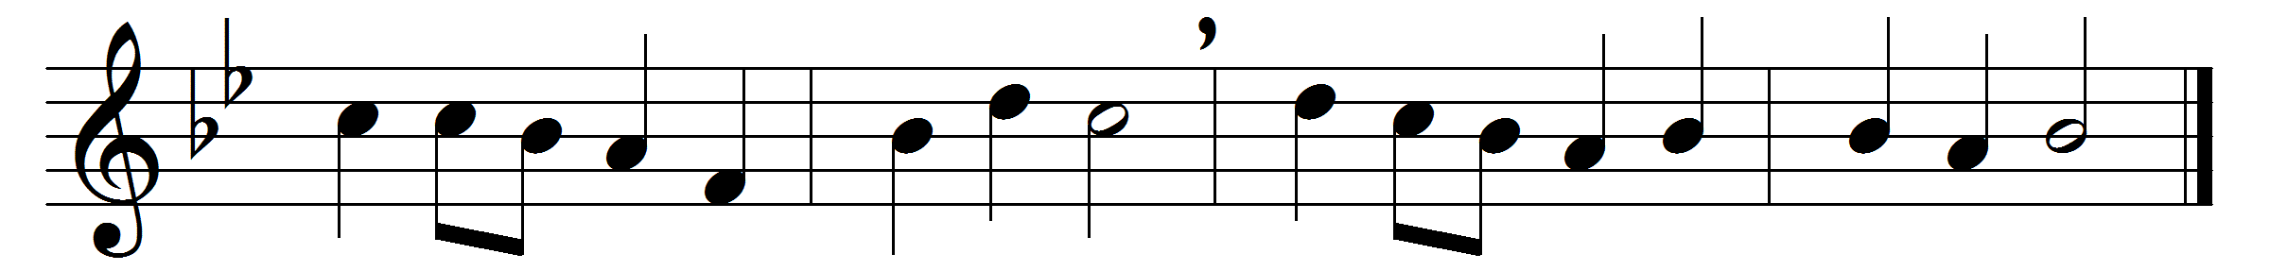

Praise, O praise our God and King;
hymns of adoration sing:
Refrain: for his mercies still endure
ever faithful, ever sure.

Praise him that he made the sun
day by day his course to run:
Refrain

And the silver moon by night,
shining with her gentle light:
Refrain

Praise him that he gave the rain
to mature the swelling grain:
Refrain

And hath bid the fruitful field
crops of precious increase yield:
Refrain

Praise him for our harvest-store;
he hath filled the garner-floor:
Refrain

And for richer food than this,
pledge of everlasting bliss:
Refrain

Glory to our bounteous King;
glory let creation sing:
glory to the Father, Son,
and blest Spirit, Three in One.

Words: John Milton (1608-1674), adapted by Henry Williams Baker (1821-1877)
Music: John Antes (1740-1811), arranged by John Wilkes (1785-1869)

