Blessed city, heavenly Salem AMNS 283 Melody: Westminster Abbey 8 7. 8 7. 8 7.
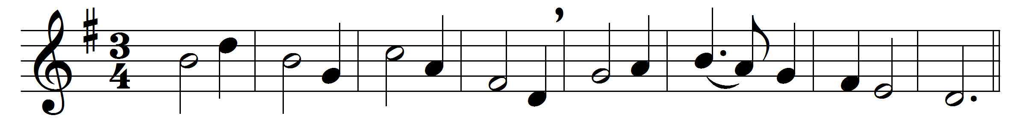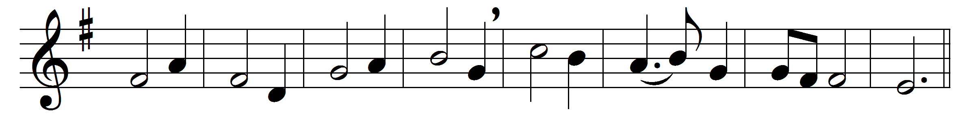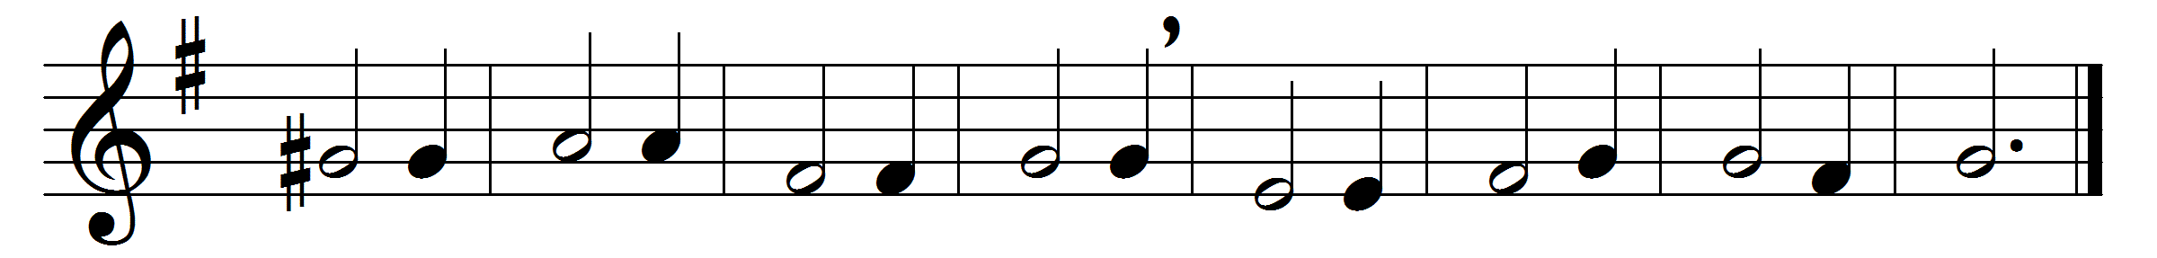

Blessèd city, heavenly Salem,
vision dear of peace and love,
who of living stones art builded
in the height of heaven above,
and by angel hosts encircled
as a bride dost earthward move!

Christ is made the sure foundation,
Christ the head and corner-stone,
chosen of the Lord, and precious,
binding all the Church in one,
holy Sion’s help for ever,
and her confidence alone.

To this temple, where we call thee,
come, O Lord of hosts, to-day;
with thy wonted loving-kindness
hear thy servants as they pray;
and thy fullest benediction
shed within its walls alway.

Here vouchsafe to all thy servants
what they ask of thee to gain,
what they gain from thee for ever
with the blessèd to retain,
and hereafter in thy glory
evermore with thee to reign.

Words: Latin, pre-9th century, translated by John Mason Neale (1818-1866)
Music: Adapted from an anthem by Henry Purcell (1659-1695)

