On Jordan’s bank the Baptist’s cry AMNS 27 Melody: Winchester New L.M.
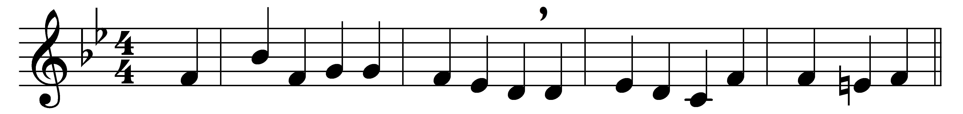

On Jordan’s bank the Baptist’s cry
announces that the Lord is nigh;
awake, and hearken, for he brings
glad tidings of the King of kings.

Then cleansed be every breast from sin;
make straight the way for God within;
prepare we in our hearts a home,
where such a mighty guest may come.

For thou art our salvation, Lord,
our refuge, and our great reward;
without thy grace we waste away,
like flowers that wither and decay.

To heal the sick stretch out thine hand,
and bid the fallen sinner stand;
shine forth, and let thy light restore
earth’s own true loveliness once more.

All praise, eternal Son, to thee
whose advent doth thy people free,
whom with the Father we adore
and Holy Ghost for evermore.

Words: Charles Coffin (1676-1749), translated by John Chandler (1806-1876)
Music: Adapted from Musicalisches Hand-Buch (Hamburg, 1690)

