My God, accept my heart this day AMNS 279 Melody: St. Peter C.M.
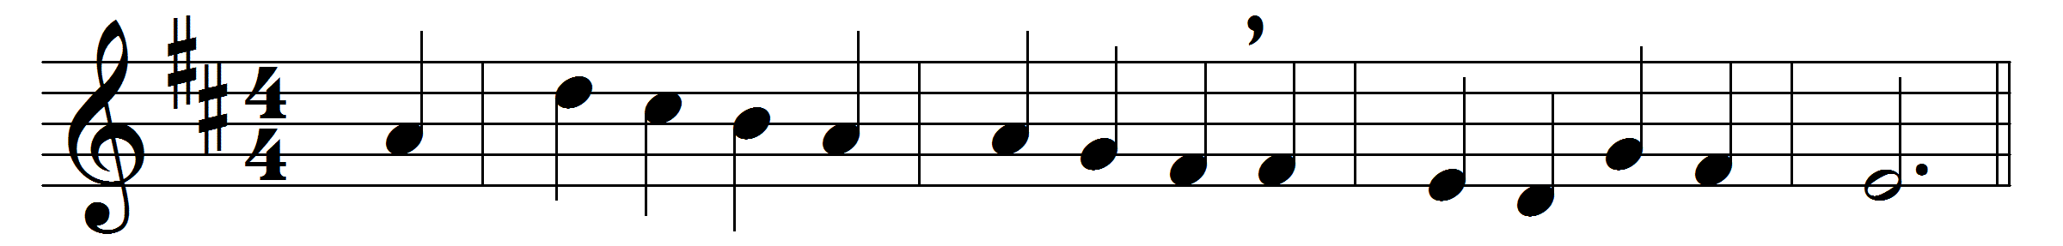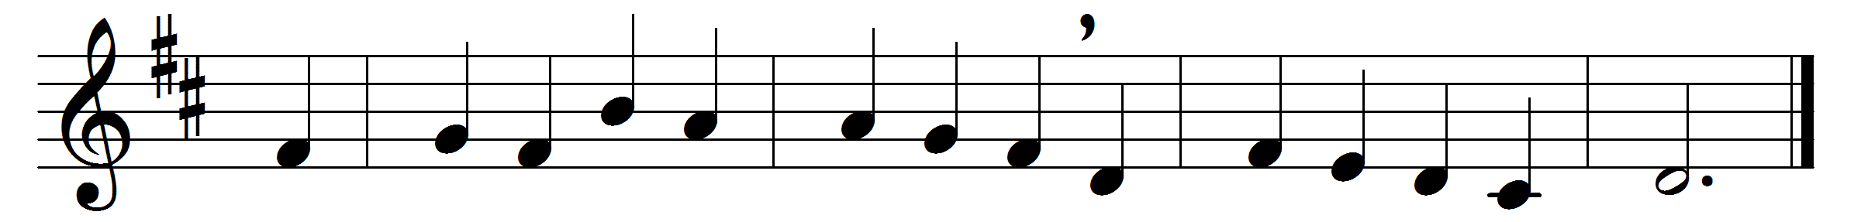

My God, accept my heart this day,
and make it always thine,
that I from thee no more may stray,
no more from thee decline.
Before the Cross of him who died,
behold, I prostrate fall;
let every sin be crucified,
and Christ be all in all.
Anoint me with thy heavenly grace,
and seal me for thine own;
that I may see thy glorious face,
and worship near thy throne.
Let every thought and work and word
to thee be ever given:
then life shall be thy service, Lord,
and death the gate of heaven.
All glory to the Father be,
all glory to the Son,
all glory, Holy Ghost, to thee,
while endless ages run.

Words: Matthew Bridges (1800-1894)
Music: Alexander Robert Reinagle (1799-1877)

