From glory to glory advancing AMNS 276 Melody: Sheen 14 14. 14 15.
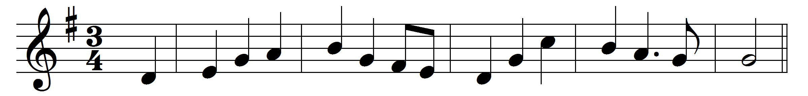

From glory to glory advancing, we praise thee, O Lord;
thy name with the Father and Spirit be ever adored.
From strength unto strength we go forward on Sion’s highway,
to appear before God in the city of infinite day.

Thanksgiving and glory and worship and blessing and love,
one heart and one song have the saints upon earth and above.
Evermore, O Lord, to thy servants thy presence be nigh;
ever fit us by service on earth for thy service on high.

Words: Liturgy of St. James, translated by Charles William Humphreys (1840-1921)
Music: Gustav Holst (1874-1934)

