Wherefore, O Father, we thy humble servants AMNS 275 Melody: Christe Fons Jugis 11 11 11. 5.
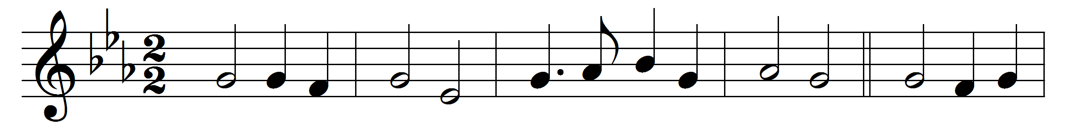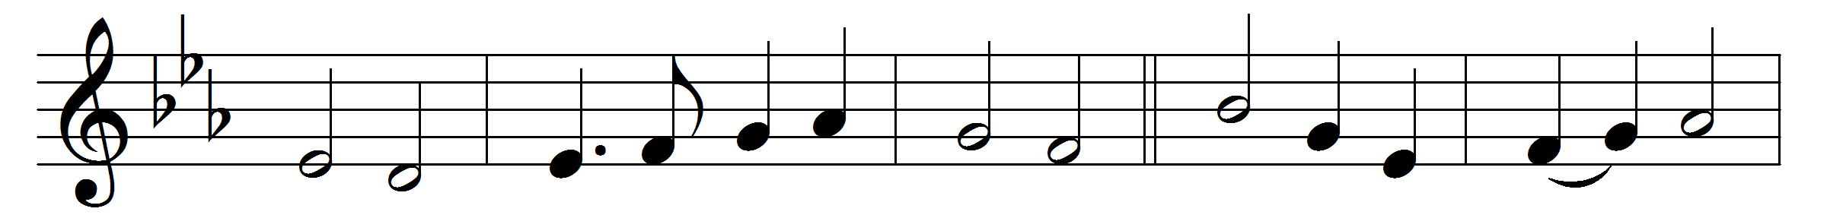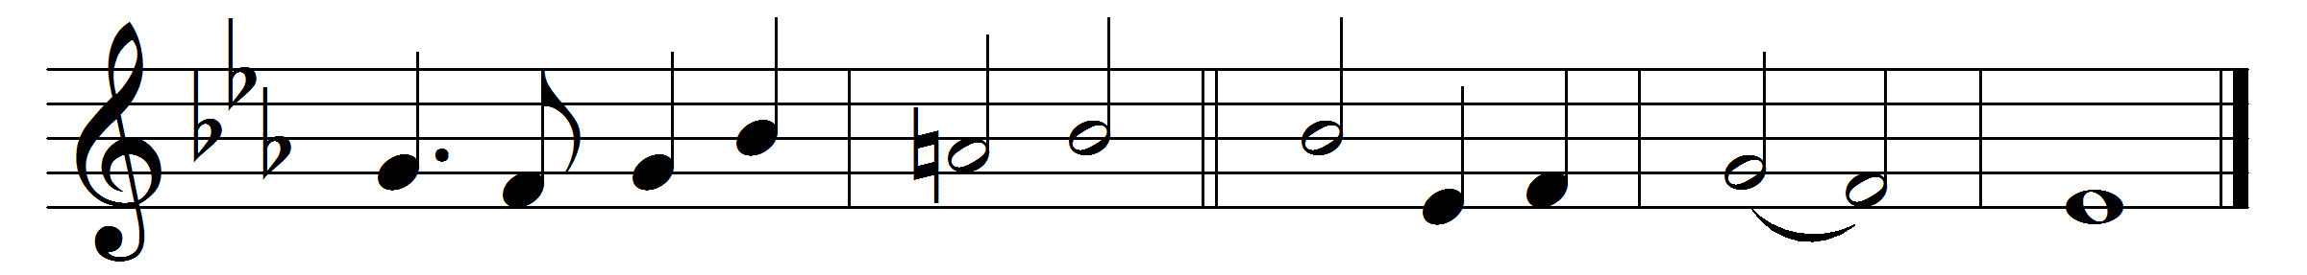

Wherefore, O Father, we thy humble servants
here bring before thee Christ thy well-belovèd,
all perfect offering, sacrifice immortal,
spotless oblation.
See now thy children, making intercession
through him our Saviour, Son of God incarnate,
for all thy people, living and departed,
pleading before thee.

Words: William Henry Hammond Jervois (1852-1905)
Music: Attributed to Philippe Goibaud Dubois (1624-1694)

