Dearest Jesu, we are here AMNS 269 Melody: Liebster Jesu 7 8. 7 8. 8 8.
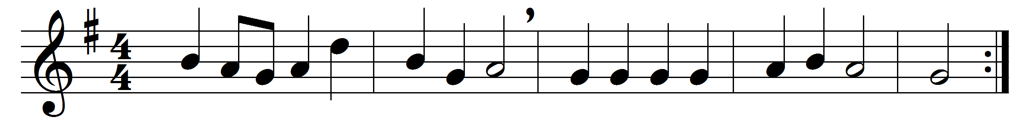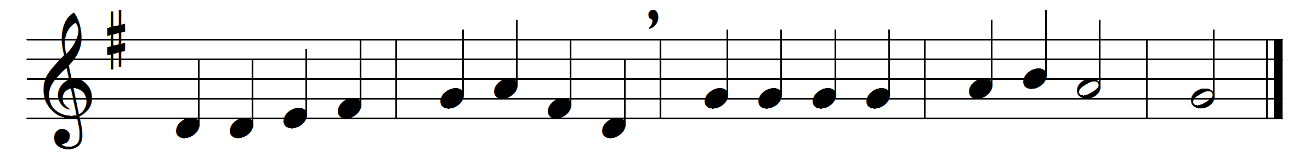

Dearest Jesu, we are here,
at thy call, thy presence owning;
pleading now in holy fear
that great sacrifice atoning:
Word incarnate, much in wonder
on this mystery deep we ponder.

Jesu, strong to save – the same
yesterday, to-day, for ever –
make us fear and love thy name,
serving thee with best endeavour:
in this life, O ne’er forsake us,
but to bliss hereafter take us.

Words: George Ratcliffe Woodward (1848-1934) after Tobias Clausnitzer (1619-1684)
Music: Johann Rudolf Ahle (1625-1673), harmonised by Johann Sebastian Bach (1685-1750)

