Almighty Father, Lord most high AMNS 267 Melody: St. Mark L.M.
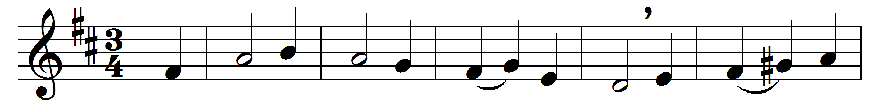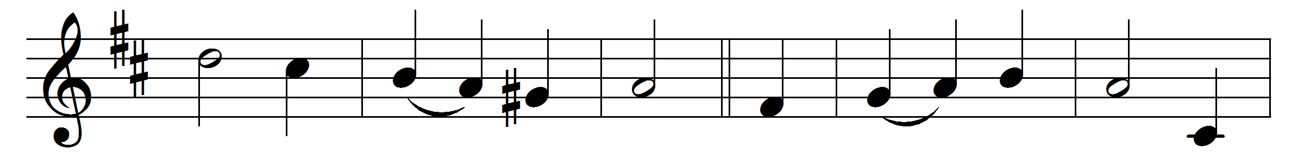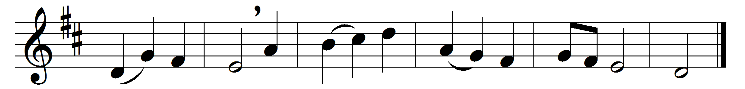

Almighty Father, Lord most high,
who madest all, who fillest all,
thy name we praise and magnify,
for all our needs on thee we call.
We offer to thee of thine own
ourselves and all that we can bring,
in bread and cup before thee shown,
our universal offering.
All that we have we bring to thee,
yet all is naught when all is done,
save that in it thy love can see
the sacrifice of thy dear Son.
By his command in bread and cup
his body and his blood we plead:
what on the Cross he offered up
is here our sacrifice indeed.
For all thy gifts of life and grace,
here we thy servants humbly pray
that thou would’st look upon the face
of thine anointed Son to-day.

Words: Vincent Stuckey Stratton Coles (1845-1929)
Music: William Crowfoot (1724-1783), from William Crisp’s Divine Harmony (1755)

