O thou, who at thy Eucharist didst pray AMNS 265 Melody: Song I 10 10. 10 10. 10 10.
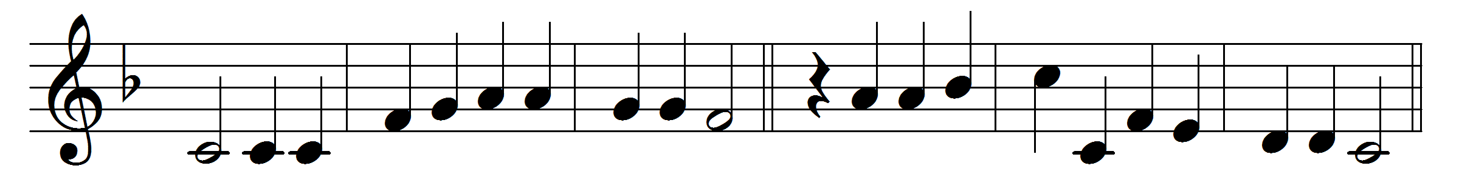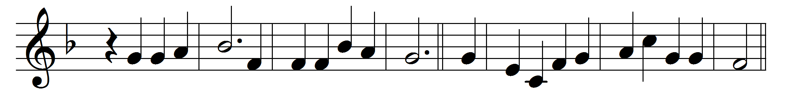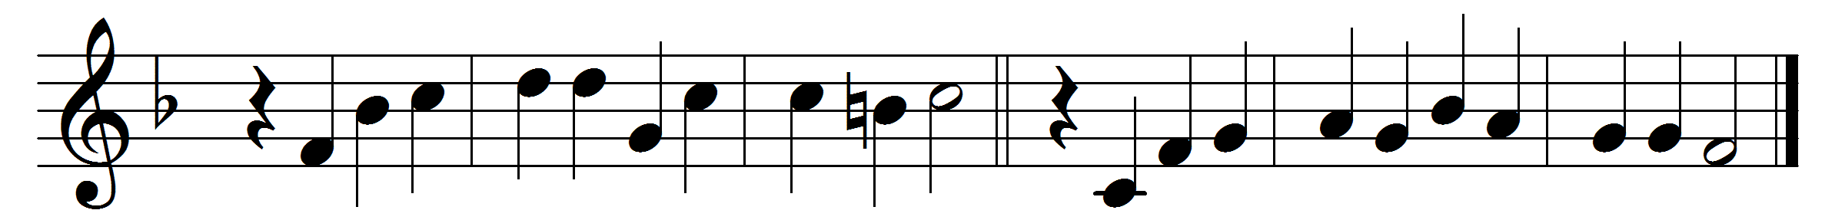

O thou, who at thy Eucharist didst pray
that all thy Church might be for ever one,
grant us at every Eucharist to say
with longing heart and soul, ‘Thy will be done:’
O may we all one bread, one body be,
through this blest sacrament of unity.
For all thy Church, O Lord, we intercede;
make thou our sad divisions soon to cease;
draw us the nearer each to each, we plead,
by drawing all to thee, O Prince of peace:
thus may we all one bread, one body be,
through this blest sacrament of unity.
We pray thee too for wanderers from thy fold;
O bring them back, good Shepherd of the sheep,
back to the faith which saints believed of old,
back to the Church which still that faith doth keep:
soon may we all one bread, one body be,
through this blest sacrament of unity.
So, Lord, at length when sacraments shall cease,
may we be one with all thy Church above,
one with thy saints in one unbroken peace,
one with thy saints in one unbounded love:
more blessèd still, in peace and love to be
one with the Trinity in Unity.

Words: William Harry Turton (1856-1938)
Music: Melody and bass by Orlando Gibbons (1583-1625)

