We pray thee, heavenly Father AMNS 264 Melody: Offertorium 7 6. 7 6. D.
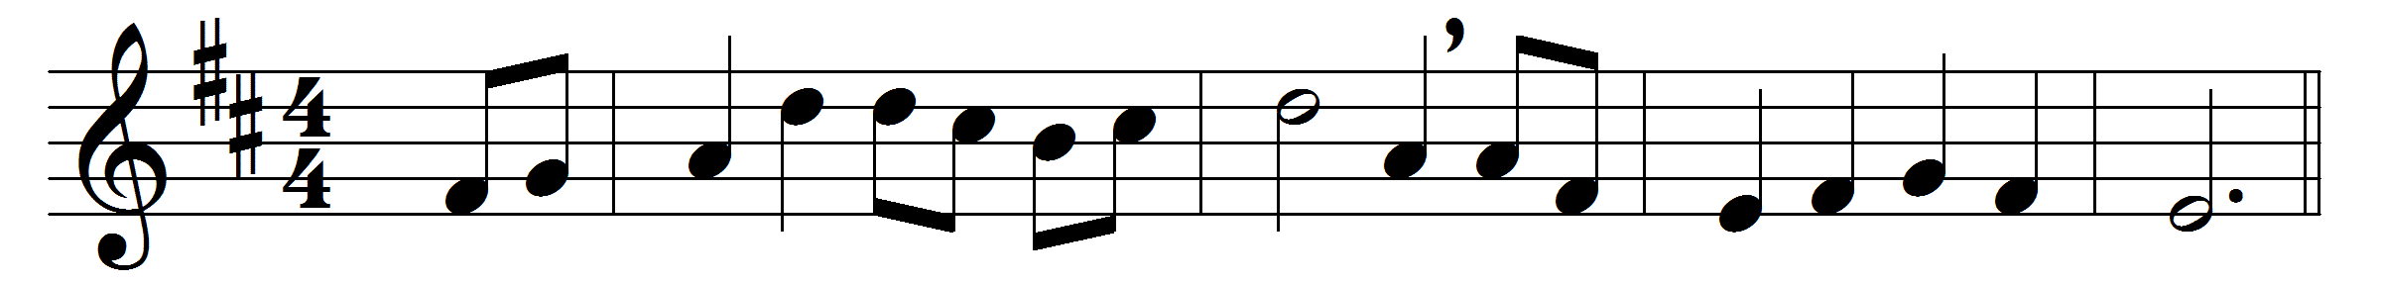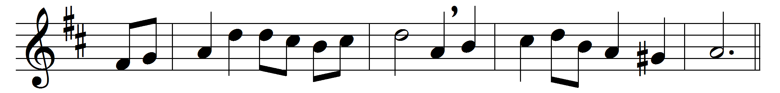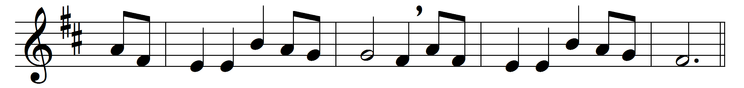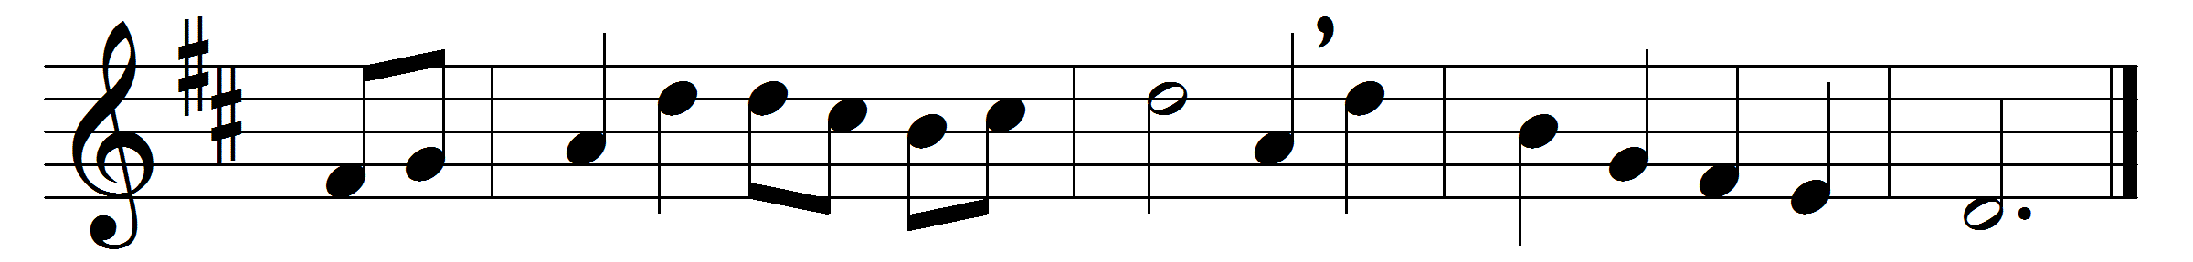

We pray thee, heavenly Father,
to hear us in thy love,
and pour upon thy children
the unction from above;
that so in love abiding,
from all defilement free,
we may in pureness offer
our Eucharist to thee.

Be thou our guide and helper,
O Jesus Christ, we pray;
so may we well approach thee,
if thou wilt be the Way:
thou, very Truth, hast promised
to help us in our strife,
food of the weary pilgrim,
eternal source of life.

And thou, creator Spirit,
look on us, we are thine;
renew in us thy graces,
upon our darkness shine;
that, with thy benediction
upon our souls outpoured,
we may receive in gladness
the body of the Lord.

O Trinity of Persons,
O Unity most high,
on thee alone relying
thy servants would draw nigh:
unworthy in our weakness,
on thee our hope is stayed,
and blessed by thy forgiveness
we will not be afraid.

Words: Vincent Stuckey Stratton Coles (1845-1929)
Music: Melody adapted from Michael Haydn (1737-1806)

