Lord, enthroned in heavenly splendour AMNS 263 Melody: St. Helen 8 7. 8 7. 8 7.
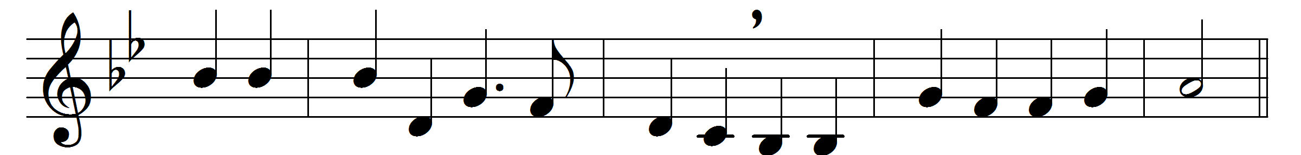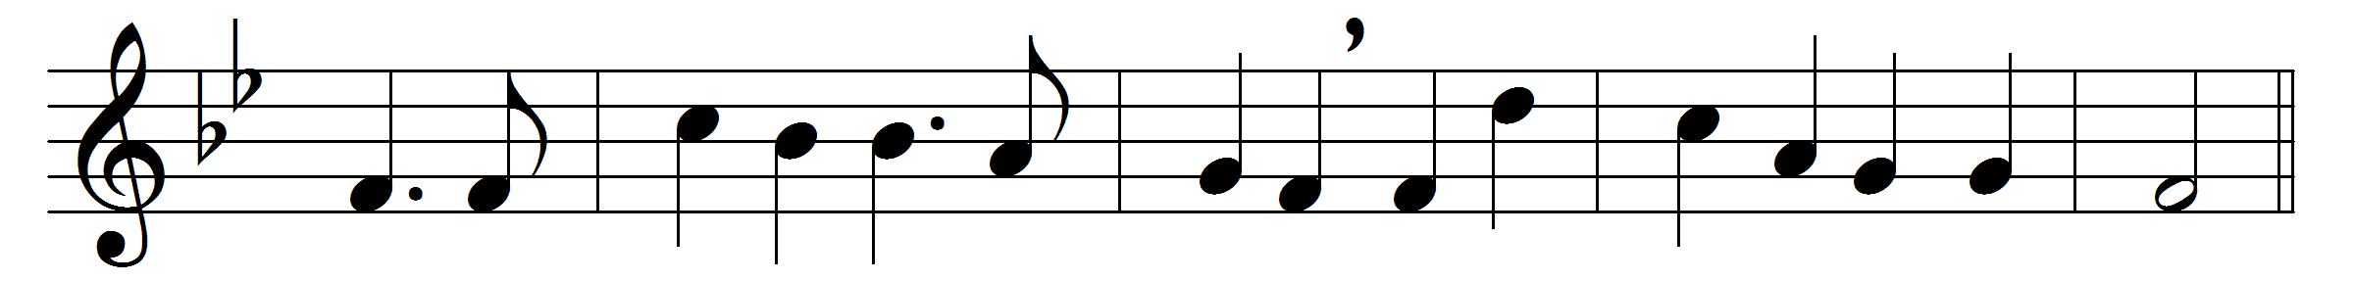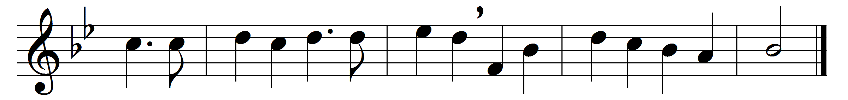

Lord, enthroned in heavenly splendour,
first-begotten from the dead,
thou alone, our strong defender,
liftest up thy people’s head.
Alleluia, Alleluia,
Jesu, true and living bread.
Here our humblest homage pay we,
here in loving reverence bow;
here for faith’s discernment pray we,
lest we fail to know thee now.
Alleluia, Alleluia,
thou art here, we ask not how.
Though the lowliest form doth veil thee
as of old in Bethlehem,
here as there thine angels hail thee,
Branch and Flower of Jesse’s Stem.
Alleluia, Alleluia,
we in worship join with them.

Paschal Lamb, thine offering, finished
once for all when thou wast slain,
in its fulness undiminished
shall for evermore remain,
Alleluia, Alleluia,
cleansing souls from every stain.
Life-imparting heavenly Manna,
stricken Rock with streaming side,
heaven and earth with loud hosanna
worship thee, the Lamb who died,
Alleluia, Alleluia,
risen, ascended, glorified.

Words: George Hugh Bourne (1840-1925)
Music: George Clement Martin (1844-1916)

