And now, O Father, mindful of the love AMNS 260 Melody: Unde et memores 10 10. 10 10. 10 10.
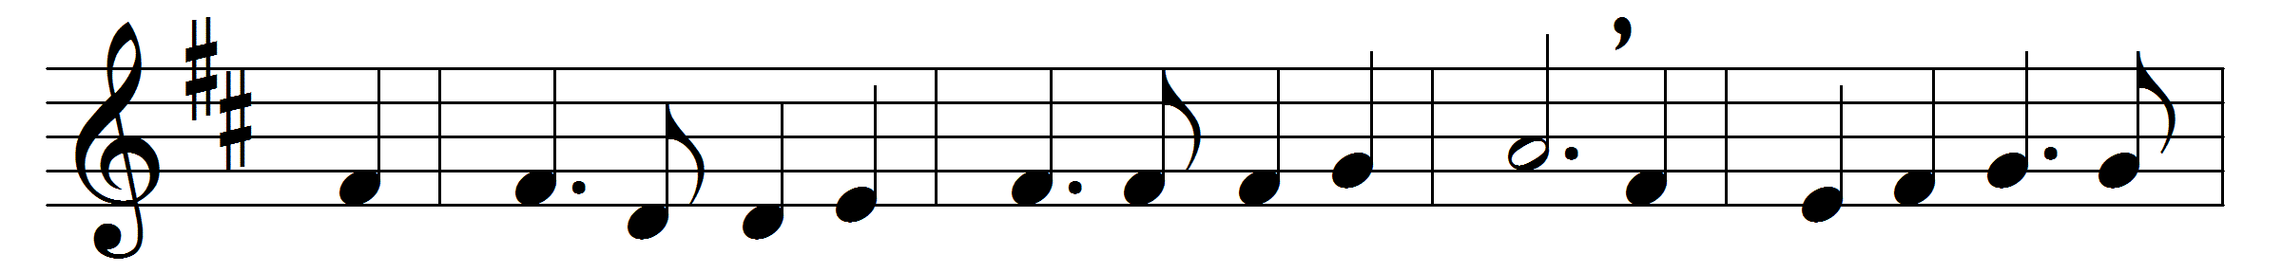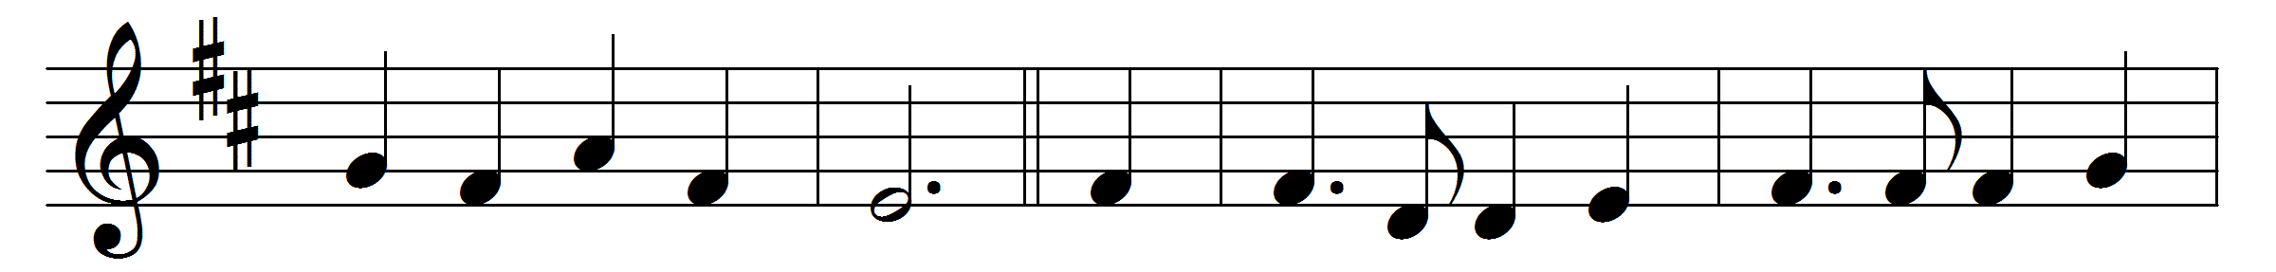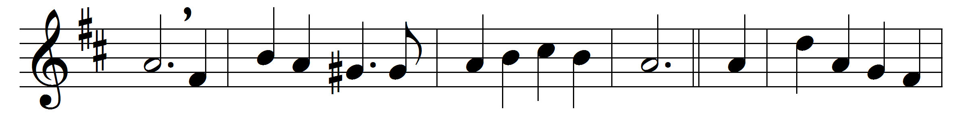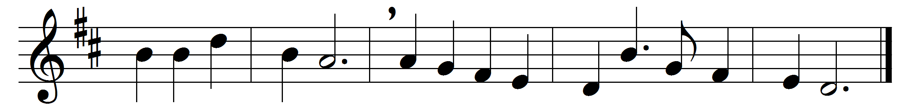

And now, O Father, mindful of the love
that bought us, once for all, on Calvary’s tree,
and having with us him that pleads above,
we here present, we here spread forth to thee
that only offering perfect in thine eyes,
the one true, pure, immortal sacrifice.

Look, Father, look on his anointed face,
and only look on us as found in him;
look not on our misusings of thy grace,
our prayer so languid, and our faith so dim:
for lo, between our sins and their reward
we set the Passion of thy Son our Lord.

And then for those, our dearest and our best,
by this prevailing presence we appeal:
O fold them closer to thy mercy’s breast,
O do thine utmost for their souls’ true weal;
from tainting mischief keep them white and clear,
and crown thy gifts with strength to persevere.

And so we come: O draw us to thy feet,
most patient Saviour, who canst love us still;
and by this food, so aweful and so sweet,
deliver us from every touch of ill:
in thine own service make us glad and free,
and grant us never more to part with thee.

Words: William Bright (1824-1901)
Music: William Henry Monk (1823-1889)

