Deck thyself, my soul, with gladness AMNS 257 Melody: Schmücke dich 8 8. 8 8. D.
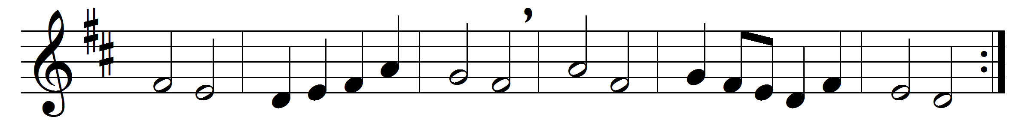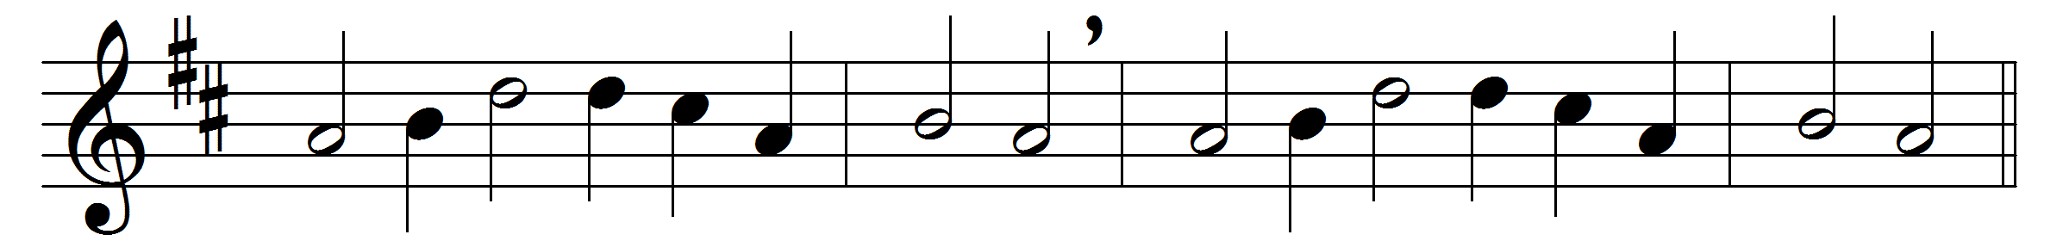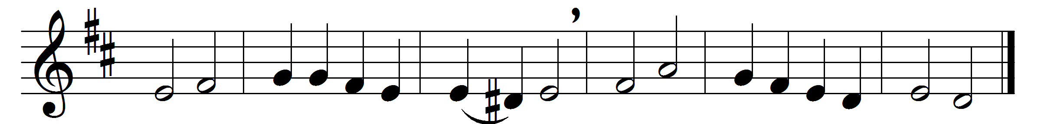

Part 1
Deck thyself, my soul, with gladness,
leave the gloomy haunts of sadness;
come into the daylight’s splendour,
there with joy thy praises render
unto him whose grace unbounded
hath this wondrous banquet founded:
high o’er all the heavens he reigneth,
yet to dwell with thee he deigneth.

Now I sink before thee lowly,
filled with joy most deep and holy,
as with trembling awe and wonder
on thy mighty works I ponder:
how, by mystery surrounded,
depth no man hath ever sounded,
none may dare to pierce unbidden
secrets that with thee are hidden.

Part 2
Sun, who all my life dost brighten,
Light, who dost my soul enlighten,
Joy, the sweetest man e’er knoweth,
Fount, whence all my being floweth,
at thy feet I cry, my Maker,
let me be a fit partaker
of this blessèd food from heaven,
for our good, thy glory, given.

Jesus, Bread of Life, I pray thee,
let me gladly here obey thee;
never to my hurt invited,
be thy love with love requited:
from this banquet let me measure,
Lord, how vast and deep its treasure;
through the gifts thou here dost give me,
as thy guest in heaven receive me.

Words: Johann Franck (1618-1677), translated by Catherine Winkworth (1827-1878)
Music: Melody by Johann Crüger (1598-1662)

