Let all mortal flesh keep silence AMNS 256 Melody: Picardy 8 7. 8 7. 8 7.
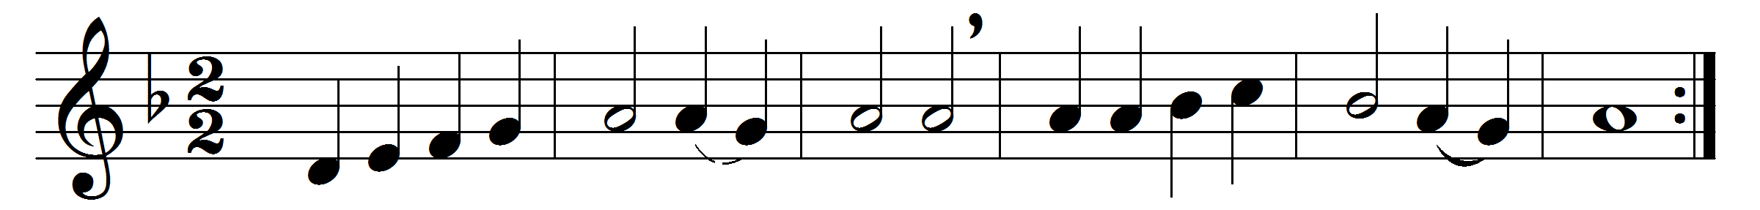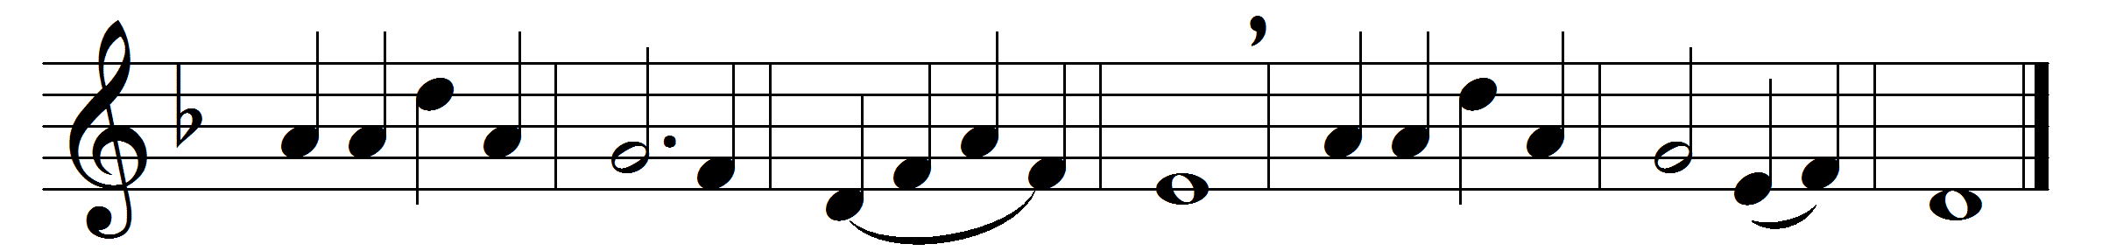

Let all mortal flesh keep silence
and with fear and trembling stand;
ponder nothing earthly-minded,
for with blessing in his hand
Christ our God to earth descendeth,
our full homage to demand.
King of kings, yet born of Mary,
as of old on earth he stood,
Lord of lords, in human vesture –
in the body and the blood –
he will give to all the faithful
his own self for heavenly food.
Rank on rank the host of heaven
spreads its vanguard on the way,
as the Light of light descendeth
from the realms of endless day,
that the powers of hell may vanish
as the darkness clears away.
At his feet the six-winged seraph;
cherubim with sleepless eye
veil their faces to the Presence,
as with ceaseless voice they cry,
Alleluia, Alleluia,
Alleluia, Lord most high.

Words: Liturgy of St. James, translated by Gerard Moultrie (1829-1885)
Music: French carol melody

