The heavenly Word, proceeding forth AMNS 253 Melody: Solemnis Haec Festivitas L.M.
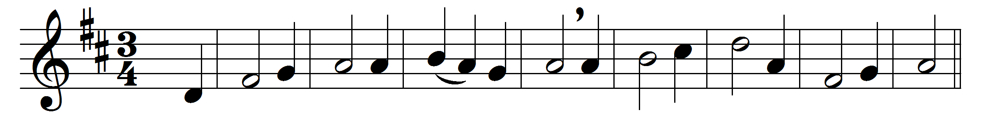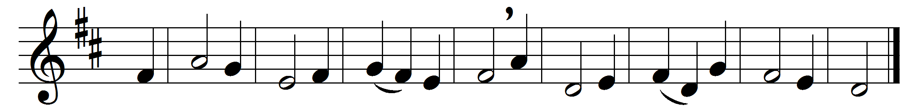

Part 1

The heavenly Word, proceeding forth
yet leaving not the Father’s side,
accomplishing his work on earth
had reached at length life’s eventide.
By false disciple to be given
to foemen for his life athirst,
himself, the very bread of heaven,
he gave to his disciples first.

He gave himself in either kind,
his precious flesh, his precious blood;
in love’s own fulness thus designed
of the whole man to be the food.
By birth their fellow-man was he,
their meat, when sitting at the board;
he died, their ransomer to be;
he ever reigns, their great reward.
Part 2

O saving Victim, opening wide
the gate of heaven to man below,
our foes press on from every side:
thine aid supply, thy strength bestow.
All praise and thanks to thee ascend
for evermore, blest One in Three;
O grant us life that shall not end
in our true native land with thee.

Words: St. Thomas Aquinas (1227-1274), St. Thomas Aquinas (1227-1274), translated by John Mason Neale (1818-1866), Edward Caswall (1814-1878), and others
Music: Melody from Paris Gradual, 1685

