Thou didst leave thy throne and thy kingly crown AMNS 250 Melody: Margaret (Irregular metre)
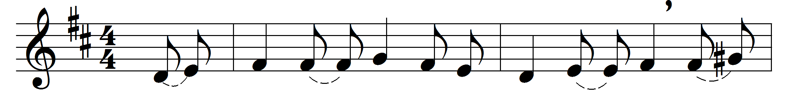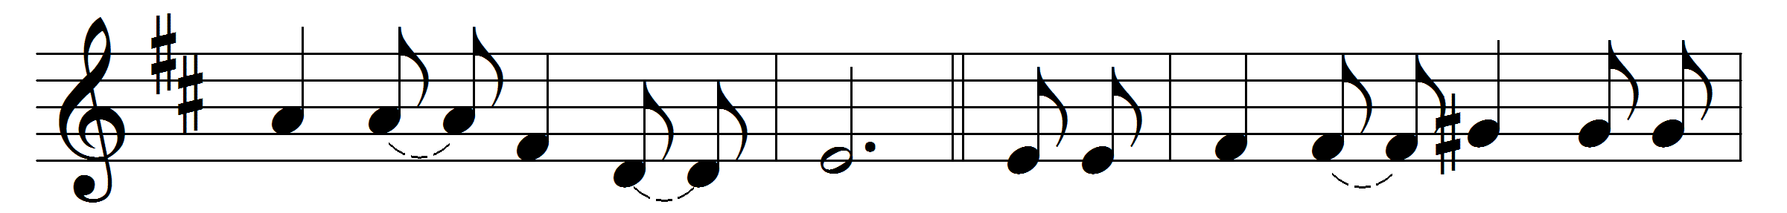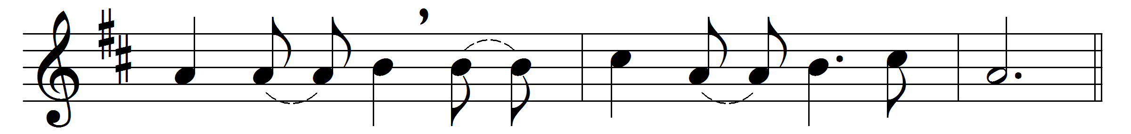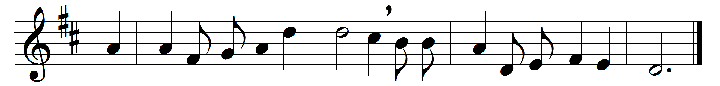

Thou didst leave thy throne and thy kingly crown,
when thou camest to earth for me;
but in Bethlehem’s home was there found no room
for thy holy nativity:
O come to my heart, Lord Jesus;
there is room in my heart for thee.
Heaven’s arches rang when the angels sang,
proclaiming thy royal degree;
but in lowly birth didst thou come to earth,
and in great humility:
The foxes found rest, and the bird had its nest
in the shade of the cedar tree;
but thy couch was the sod, O thou Son of God,
in the desert of Galilee:

Thou camest, O Lord, with the living word
that should set thy people free;
but with mocking scorn and with crown of thorn
they bore thee to Calvary:
When the heavens shall ring, and the angels sing,
at thy coming to victory,
let thy voice call me home, saying, ‘Yet there is room,
there is room at my side for thee:’
O come to my heart, Lord Jesus;
there is room in my heart for thee.
Words: Emily Elizabeth Steele Elliott (1836-1897)
Music: Timothy R. Matthews (1826-1910)

