I heard the voice of Jesus say AMNS 247 Melody: Vox dilecti D.C.M.
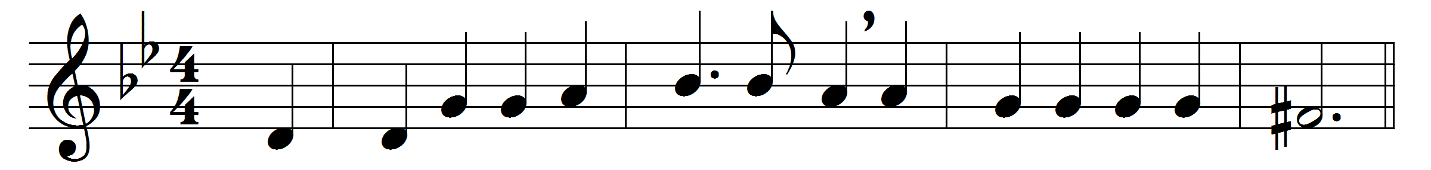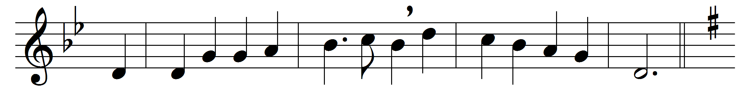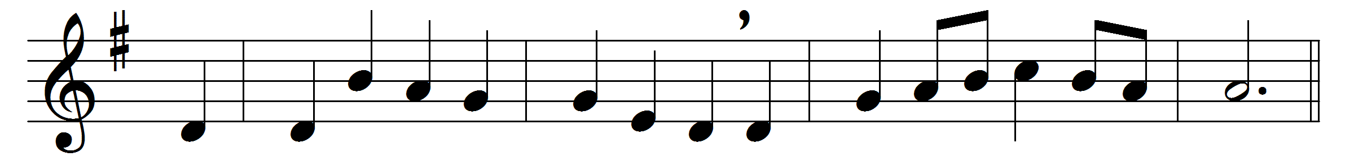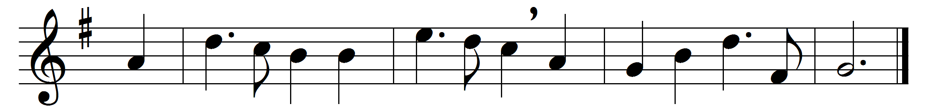

I heard the voice of Jesus say,
‘Come unto me and rest;
lay down, thou weary one, lay down
thy head upon my breast:’
I came to Jesus as I was,
so weary, worn and sad;
I found in him a resting-place,
and he has made me glad.
I heard the voice of Jesus say,
‘Behold, I freely give
the living water, thirsty one;
stoop down and drink and live:’
I came to Jesus, and I drank
of that life-giving stream;
my thirst was quenched, my soul revived,
and now I live in him.
I heard the voice of Jesus say,
‘I am this dark world’s light;
look unto me, thy morn shall rise,
and all thy day be bright:’
I looked to Jesus, and I found
in him my star, my sun;
and in that light of life I’ll walk
till travelling days are done.

Words: Horatius Bonar (1808-1889)
Music: John Bacchus Dykes (1823-1876)

