Just as I am, without one plea AMNS 246 Melody: Saffron Walden 8 8 8. 6.
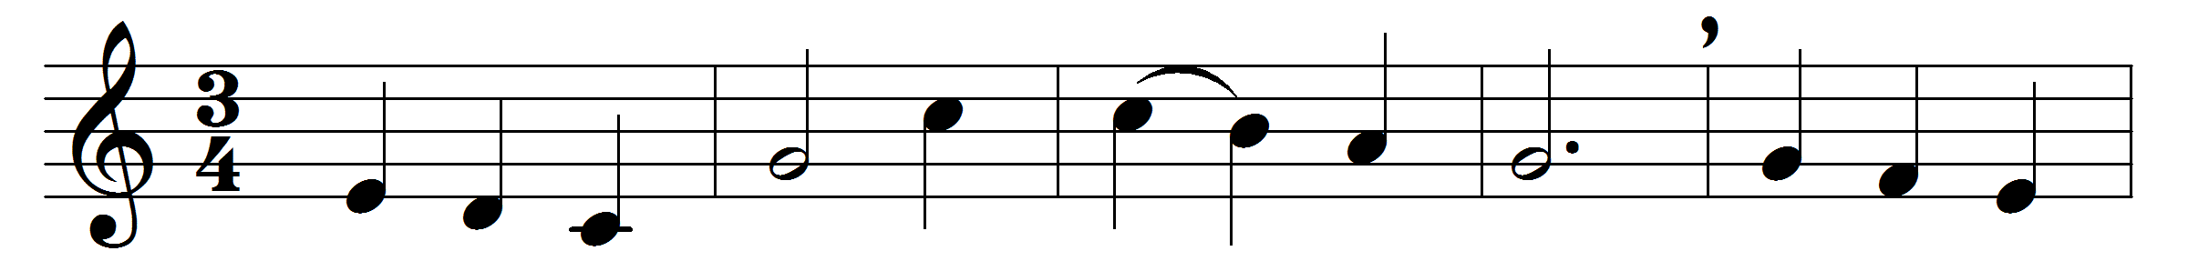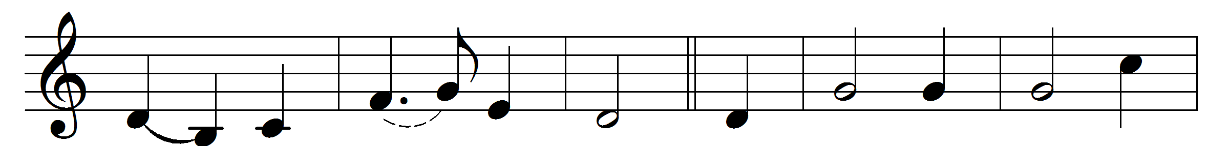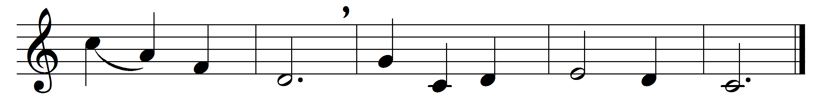

Just as I am, without one plea
but that thy blood was shed for me,
and that thou bidst me come to thee,
O Lamb of God, I come.
Just as I am, though tossed about
with many a conflict, many a doubt,
fightings and fears within, without,
O Lamb of God, I come.
Just as I am, poor, wretched, blind;
sight, riches, healing of the mind,
yea, all I need, in thee to find,
O Lamb of God, I come.
Just as I am, thou wilt receive,
wilt welcome, pardon, cleanse, relieve:
because thy promise I believe,
O Lamb of God, I come.
Just as I am (thy love unknown
has broken every barrier down),
now to be thine, yea, thine alone,
O Lamb of God, I come.
Just as I am, of that free love
the breadth, length, depth, and height to prove,
here for a season, then above,
O Lamb of God, I come.

Words: Charlotte Elliott (1789-1871)
Music: Arthur Henry Brown (1830-1926)

