Hark, my soul, it is the Lord AMNS 244 Melody: St. Bees 7 7. 7 7.
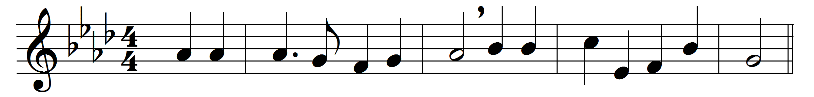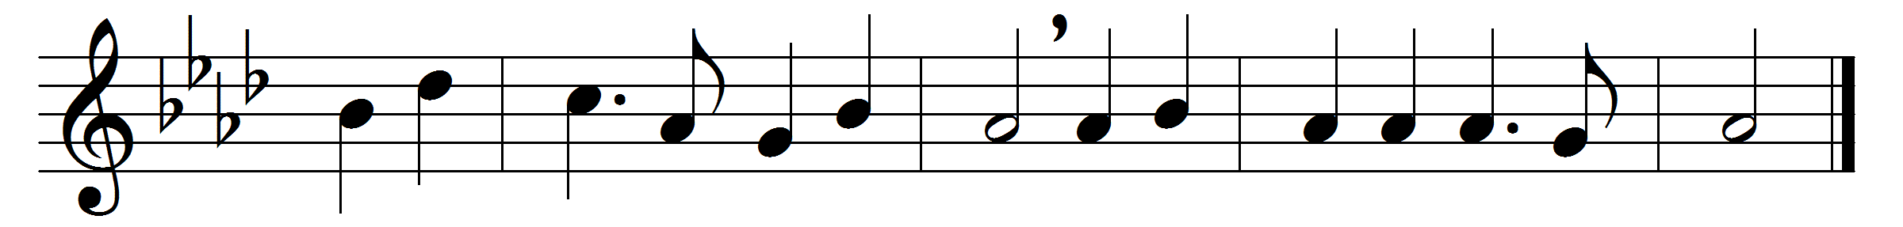

Hark, my soul, it is the Lord;
’tis thy Saviour, hear his word;
Jesus speaks, and speaks to thee,
‘Say, poor sinner, lov’st thou me?

‘I delivered thee when bound,
and, when wounded, healed thy wound;
sought thee wandering, set thee right,
turned thy darkness into light.

‘Can a woman’s tender care
cease towards the child she bare?
yes, she may forgetful be,
yet will I remember thee.

‘Mine is an unchanging love,
higher than the heights above,
deeper than the depths beneath,
free and faithful, strong as death.

‘Thou shalt see my glory soon,
when the work of grace is done;
partner of my throne shalt be:
say, poor sinner, lov’st thou me?’

Lord, it is my chief complaint
that my love is weak and faint;
yet I love thee, and adore;
O for grace to love thee more!

Words: William Cowper (1731-1800)
Music: John Bacchus Dykes (1823-1876)

